Software Requirements Specification for

Hospital Management System

**Version 4.0**

**Prepared by:**

1. **Đinh Gia Kiệt – 2252399**

**Faculty of Computer Science and Engineering**

**Ho Chi Minh City University of Technology – VNU-HCM**

**<11_2_2025>**

**Table of Contents**

**1. Requirement elicitation 1**

1.1 Domain Context 1

1.2 Stakeholders and Needs 1

1.3 Benefits of the System 2

1.4 Functional Requirements 2

1.5 Non- Functional Requirements 4

**2. Use-case Diagrams 5**

2.1 Use-case Diagram for the Whole System 5

2.2 Use-case Diagram and specification for each Module 5 6

**3. System modeling 9**

3.1 Activity diagram to capture the business process between systems and the stakeholders 10

3.2 Sequence diagram 14

**4. Architecture Design 26**

4.1 Architecture Diagram. 26

4.2 Architecture breakdown 28

**Reference: 36**

**Revision History**

|  |  |  |  |
| --- | --- | --- | --- |
| **Name** | **Date** | **Reason For Changes** | **Version** |
| Đinh Gia Kiệt | 11/02 | Updated task 1, added domain context, stakeholders and their needs, function requirement, non-functional requirement. | 1.0 |
| Trần Nguyễn Anh Khoa | 18/02 | Updated task 2, added use-case diagram for the whole system and for each module, added use-case scenario and specification. | 1.1 |
| Đinh Gia Kiệt | 25/02 | Updated task 3, added activity diagrams, sequence diagrams. | 2.0 |
| Đinh Gia Kiệt | 1/3 | Updated task 4, added architecture design and description | 3.0 |
| Đinh Gia Kiệt | 4/03 | Updated task 5, updated last tasks. | 4.0 |
|  |  |  |  |

# Task 1: Requirement elicitation (1.1, 1.2)

## Domain Context

The Hospital Management System (HMS) is intended to digitally transform the operational management processes within healthcare facilities, specifically enhancing efficiency and effectiveness across multiple functional areas. It aims to digitally transform critical processes such as patient management, appointment scheduling, billing, and staff administration. The system's primary objectives include digitally transforming patient management to facilitate comprehensive medical record management and patient detail retrieval. Additionally, the HMS seeks to optimize appointment scheduling processes, significantly enhancing patient satisfaction and effectively utilizing medical resources. Automating billing systems is another critical goal, ensuring precise financial transactions, efficient payment processing, and streamlined invoice generation. Furthermore, staff management improvements through the system will empower the effective administration of hospital staff, including doctors, nurses, and administrative personnel, by managing profiles, scheduling shifts, and monitoring staff performance.

The project scope explicitly encompasses core functionalities of patient management, appointment scheduling, billing, and staff management. For patient management, the system will digitize patient records, medical history management, and patient information retrieval. Appointment scheduling functionality will cover patient appointment booking, status updates, and doctor availability management. Billing functionality will manage patient financial interactions, payments, and invoice production. Lastly, the staff management module will facilitate the effective administration of doctors and nurses, including managing their profiles, shifts, and performance tracking.

Furthermore, the HMS incorporates non-functional requirements to ensure robust performance. These include ensuring the scalability of system functionalities, maintaining flexibility through interfaces and abstract classes to facilitate seamless adaptability and extensions, and guaranteeing reliability through consistent performance and accurate data management. The system's architectural design will adhere to SOLID principles, enhancing maintainability and flexibility, allowing for future extensions and modifications without affecting the existing system's integrity.

## Stakeholders and Needs

### Stakeholders:

- Patient(End users)

- Administrator (System managers)

- Doctor (End user)

- Nurse (End user)

### Students’ needs

Patients require the ability to log in to the system, manage their personal profiles, and book appointments with doctors conveniently.

### Administrator’s needs

Administrators need to log in to the system to add or remove staff members from the system, ensuring effective management of hospital resources.

### Doctor’s needs

Doctors require logging into the system, managing their user profiles, updating medical and health information in patient records, and retrieving patient details efficiently.

### Nurse’s needs

Nurses need to log into the system, manage their user profiles, and efficiently retrieve patient details for patient care.

## Benefits of the System

The Hospital Management System (HMS) offers key benefits including efficient patient registration, streamlined management of appointments, optimized billing processes, and effective staff scheduling. The modular design ensures maintainability, scalability, flexibility, and extensibility, significantly reducing administrative workload and enhancing operational effectiveness. Moreover, the HMS ensures robust data handling, providing precise and timely information to stakeholders.

## Functional Requirements

**Administrator:** is the main user of the system. Following functionality can be done by the administrator

- Login to the system.

- Add/remove staff members from the system

**Doctor:** play a main role in the system, they work in the press, except the administrator who also has the privileges as Staff Member in this system. Following functionalities can be done by a Staff Member

- Login to the system.

- Manage user profiles.

- Retrieve patient details

- Update medical and health information in patient records.

**Nurse:**

- Login to the system.

- Manage user profiles.

- Retrieve patient details.

**Students** used to engage with the service from HCMUT_SSPS frequently. Following privileges are available for the students:

- Login.

- Manage user profiles.

- Account registration

- Book appointments with doctors

- View the bill details.

- Make a payment.

## Non- Functional Requirements

Nonfunctional requirements are the requirement that specifies criteria that can be used to judge the operation of a system, rather than specific behaviors. They are contrasted with functional requirements that define specific behavior or functions.

**1.  Maintainability**

The system should be designed with clear, modular, and well-documented code to facilitate easy debugging, enhancement, and refactoring. Additionally, it should incorporate logging and error-handling mechanisms to assist in troubleshooting and to simplify future updates.

**2.  Scalability**

The HMS should be capable of managing a continuously growing number of patients, appointments, staff members, and billing transactions as the hospital expands. Specifically, the Patient Management and Appointment Scheduling functionalities must efficiently handle increasing volumes of patient data without any degradation in performance. Furthermore, the system needs to seamlessly accommodate additional staff and doctors, including their schedules and work logs, ensuring smooth scalability as the hospital's network of healthcare providers grows.

**3.  Extensibility**

The system must allow for the addition of new modules to be simple to integrate into the existing system with minimal rework.

**4. Flexibility**

The HMS should be adaptable to meet the varying needs of individual hospitals, allowing customization in areas such as patient record management and appointment scheduling. It should also provide flexibility in adjusting user roles and permissions, for example, granting doctors greater access to patient data compared to nurses. Additionally, the Staff Management module must support diverse staffing models, enabling variations in shift scheduling and management tailored to each hospital's specific operational requirements.

**5. Modularity**

The HMS should be designed with distinct, independently deployable modules, ensuring that modifications to one component do not negatively impact others. Each functionality—including Patient Management, Appointment Scheduling, Billing, and Staff Management—should be self-contained, facilitating updates or adjustments within one module without disrupting the operation of the others. This modular approach allows hospitals to individually scale and upgrade different parts of the system independently, minimizing system downtime and operational disruption.

# Use-case Diagrams

## Use-case Diagram for the Whole System



**Hopital Management System**

**2.2 Use-case Diagram for each Module**

**Use-case Diagram for Patient Module**

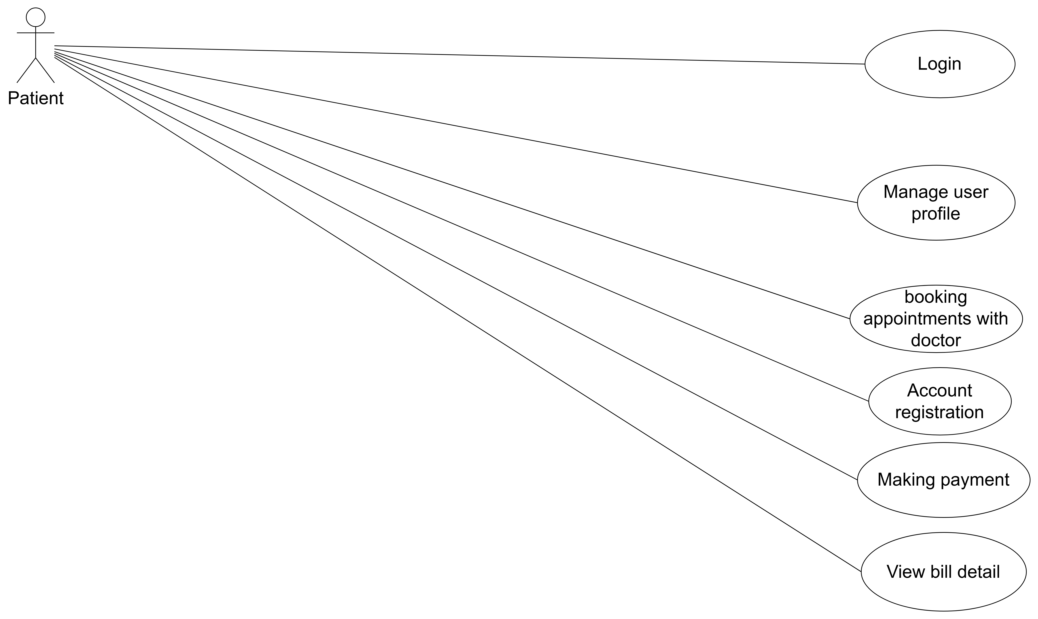

**Use-case for Patient module**

## The Use-cases specification of Patient Module

1. **Usecase Login**

|  |  |
| --- | --- |
| **Use Case Name** | **Login** |
| **Actor(s)** | Patient |
| **Description** | Patient logs into the system using the credential information. |
| **Precondition(s)** | - Patient has valid credentials information. - The system is online  - authentication service is available.  - Network connectivity is stable |
| **Trigger** | The Patient selects "Login." in the application interface. |
| **Main Flow** | 1. The system prompts the Patient to enter their username and password. 2. The Patient enters valid credentials and submits the login request. 3. The system securely sends these credentials to the authentication service. 4. authentication service verifies the credentials and confirms authenticity. 5. Upon successful verification, the system creates an authenticated user session. 6. The Patient gains access to the system functionalities. |
| **Alternate Flow(s)** | **Invalid credentials:** 4. The system shows an error message  5. The student can retry logging |
| **Postcondition(s)** | - The student is authenticated, and a secure session is established. - The student has access to permitted features according to their role and permissions. |
| **Exceptions** | - Network errors or connection instability preventing credential verification. - Authentication service downtime. - System errors preventing login completion. - Unexpected errors causing session management failure. |

1. **Usecase Manage User Profile**

|  |  |
| --- | --- |
| **Use Case Name** | **Manage User Profile** |
| **Actor(s)** | Patient |
| **Description** | The Patient can view and update personal information, including name, email, and contact details. |
| **Precondition(s)** | - The Patient must be logged into the system. - The system verifies the user's permissions to manage their profile. |
| **Trigger** | The Patientselects the "Profile" section from the application interface. |
| **Main Flow** | 1. The system retrieves and displays the Patient’s current profile details. 2. The Patient edits the profile information and submits changes. 3. The system validates the input data. 4. Upon successful validation, the system saves the profile updates. 5. The system displays a confirmation message indicating successful update. |
| **Alternate Flow(s)** | **Invalid data entered:** 1. The system identifies and highlights specific input fields with invalid or incomplete data. 2. The system displays clear error messages describing the validation issues. 3. The Patient corrects the indicated errors. 4. The Patient resubmits the updates, returning to step 2 of the main flow. |
| **Postcondition(s)** | - The Patient’s profile is successfully updated in the system. |
| **Exceptions** | - Network connectivity issues or system errors could prevent updates, prompting an error message. - In case of persistent errors or system failures, the update is not saved, and the Patient is notified accordingly. |

## Usecase Booking appointment with doctor

|  |  |
| --- | --- |
| **Use Case Name** | **Booking appointment with doctor** |
| **Actor(s)** | Patient |
| **Description** | The patient schedules an appointment with a specific doctor, selecting date, time. |
| **Precondition(s)** | - The patient must be logged into the HMS. - The patient's profile must be active and verified. - Doctors' availability schedules must be accessible. - Appointment slots must be available for selection. |
| **Trigger** | The patient selects "Book Appointment" in the HMS interface. |
| **Main Flow** | 1. The system displays available doctors and their schedules. 2. The patient selects the preferred doctor, date, and time. 3. The patient selects the type of appointment (e.g., consultation, follow-up). 4. The system validates the chosen appointment slot's availability. 5. Upon validation, the patient confirms the booking. 6. The system saves the appointment details. 7. The patient receives an appointment confirmation notification. |
| **Alternate Flow(s)** | **Selected appointment unavailable:** 1. System notifies the patient that the chosen slot is no longer available and suggests alternative slots. 2. Patient selects a new slot and continues booking process at step 3 of the main flow.  **Incomplete appointment details:** 1. System prompts the patient to provide missing required information. 2. Patient fills in missing details and continues booking at step 5 of main flow. |
| **Postcondition(s)** | - Appointment successfully scheduled and visible in patient's appointments list. - Doctor's schedule updated to reflect the booked appointment. - Appointment details logged for administrative purposes. - Patient and doctor receive confirmation notifications. |
| **Exceptions** | - System/network errors preventing appointment scheduling. - Doctor's availability changing suddenly (e.g., emergency cancellation), causing booking disruption. - Persistent validation errors preventing booking completion. |

## UseCase Account Registration

|  |  |
| --- | --- |
| **Use Case Name** | **Account Registration** |
| **Actor(s)** | Patient |
| **Description** | A new patient creates an account in the HMS to access system features such as booking appointments and managing their profile. |
| **Precondition(s)** | - The HMS is online and accessible. - Patient does not already have an existing account. |
| **Trigger** | The patient selects the "Register" option from the HMS login interface. |
| **Main Flow** | 1.The system displays the account registration form. 2.The patient enters required information (e.g., full name, date of birth, email, phone number, username, password). 3.The system validates the input information. 4.The system checks if the entered email or username is already registered. 5.The patient receives confirmation of successful registration. |
| **Alternate Flow(s)** | **Invalid or incomplete information:** 1. The system highlights fields with missing or invalid information and provides clear validation messages. 2. The patient corrects the highlighted fields and resubmits (returns to step 3 in the main flow).  **SSNalready registered:** 1. The system informs the patient that the chosen SSN is already in use. 2. The patient selects alternative details and resubmits (returns to step 3). |
| **Postcondition(s)** | - A new patient account is created and activated. - The patient gains access to HMS functionalities like appointment scheduling and profile management. - The patient's registration details are securely stored in the system database. - Registration event is logged by the system for auditing purposes. |
| **Exceptions** | - System or network errors preventing registration completion. - Email service unavailable, preventing delivery of verification emails. - Persistent validation errors preventing account creation. |

## Usecase View bill detail

|  |  |
| --- | --- |
| **Use Case Name** | **View bill detail** |
| **Actor(s)** | Patient |
| **Description** | The patient views detailed billing information for their medical services, including charges, due dates, and payment status. |
| **Precondition(s)** | - The patient must be logged into the HMS. - Billing information must be generated and available in the patient's account. - The patient has existing billing records. |
| **Trigger** | The patient selects the "Billing" or "View Bill Details" option in their account dashboard. |
| **Main Flow** | 1. The system retrieves and displays a summary list of the patient's bills. 2. The patient selects a specific bill from the displayed list. 3. The system fetches and presents detailed information about the selected bill, including services provided, individual charges, total amount due, payment due date, and payment status. 4. The patient reviews the detailed billing information. |
| **Alternate Flow(s)** | **No bill details available:** 1. The system displays a message indicating there are no available billing details.   **System delay or error loading details:** 1. The system informs the patient of a temporary issue and advises trying again later. 2. The patient retries viewing details after some time (returns to step 1 of the main flow). |
| **Postcondition(s)** | - Patient successfully views detailed billing information. - Billing records remain unchanged after viewing. |
| **Exceptions** | - System errors or network issues preventing bill details retrieval. - Access permissions error, restricting patient's ability to view bill details. |

## Usecase Making payment

|  |  |
| --- | --- |
| **Use Case Name** | **Making payment** |
| **Actor(s)** | Patient |
| **Description** | The patient pays outstanding medical bills through the HMS payment gateway. |
| **Precondition(s)** | - Patient must be logged into the HMS. - Patient has outstanding billing transactions. - Payment gateway must be operational and accessible. - Patient has valid payment methods available (e.g., credit/debit card, online banking, e-wallet). |
| **Trigger** | Patient selects the "Pay Bill" or "Make Payment" option from the billing section. |
| **Main Flow** | 1. The system displays a list of unpaid bills with outstanding amounts. 2. Patient selects the bill(s) they wish to pay. 3. The system shows the total amount payable and prompts for payment method selection. 4. Patient selects the preferred payment method and enters necessary payment details. 5. System securely verifies payment details and processes the transaction. 6. Upon successful payment confirmation from the payment gateway, the system updates the bill status as "Paid." 7. Patient receives a confirmation receipt or payment notification. 8. Patient is returned to updated billing summary. |
| **Alternate Flow(s)** | **Payment unsuccessful (e.g., insufficient funds, declined payment):** 1. System informs the patient of payment failure with a clear explanation. 2. Patient can retry the payment using the same or an alternative method (returns to step 4 of the main flow).  **Payment Gateway Unavailable:** 1. System displays a notification of payment gateway unavailability. 2. Patient advised to attempt payment later. 3. Patient returns to the billing summary. |
| **Postcondition(s)** | - Bill status updated to reflect successful payment. - Payment transaction is recorded securely in the system. - Receipt or proof of payment is generated and stored. - Payment confirmation notification sent to patient. |
| **Exceptions** | - Network or system errors disrupting the payment process. - Payment service outage causing transaction failure. - Persistent verification or validation errors preventing payment completion. |

## Use-case Diagram for Doctor Module

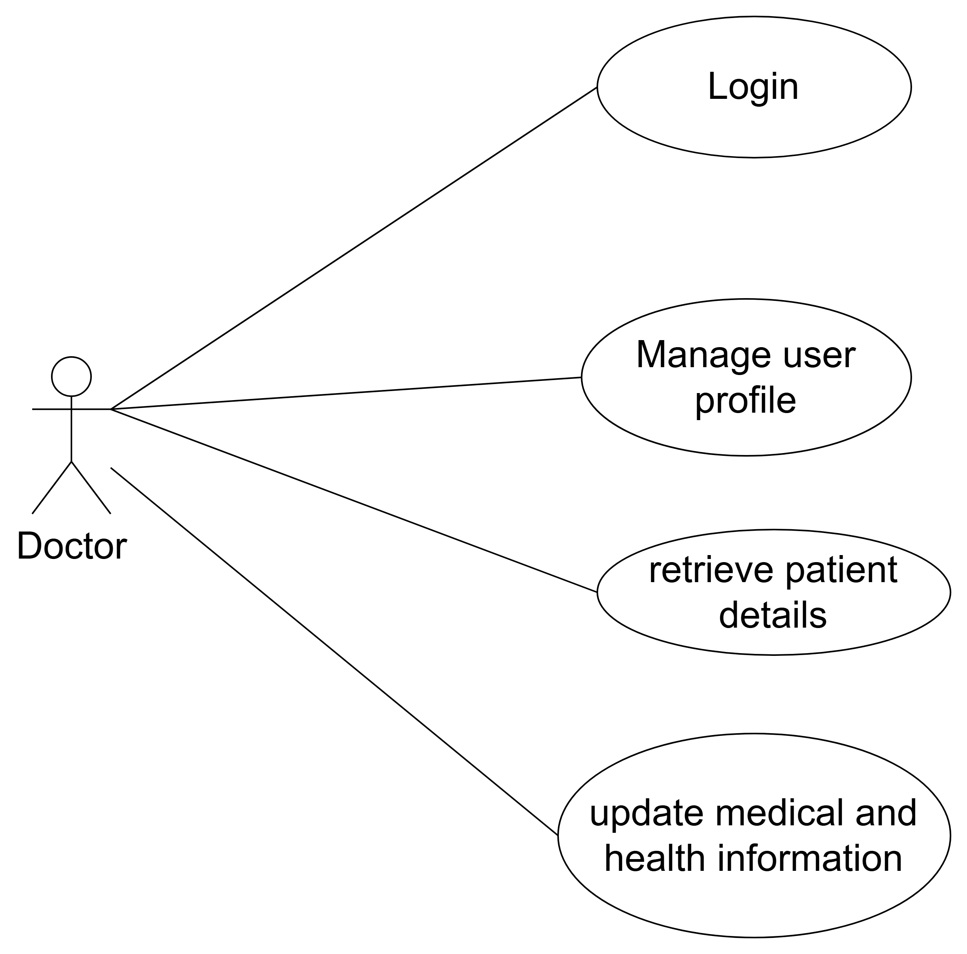

**Use-case for Doctor module**

## The Use-cases specification of Doctor Module

**1. Usecase Login**

|  |  |
| --- | --- |
| **Use Case Name** | **Login** |
| **Actor(s)** | Doctor |
| **Description** | Doctor logs into the system using the credential information. |
| **Precondition(s)** | - Doctor has valid credentials information. - The system is online  - authentication service is available.  - Network connectivity is stable |
| **Trigger** | The Doctor selects "Login." in the application interface. |
| **Main Flow** | 1. The system prompts the Doctor to enter their username and password. 2. The Doctor enters valid credentials and submits the login request. 3. The system securely sends these credentials to the authentication service. 4. authentication service verifies the credentials and confirms authenticity. 5. Upon successful verification, the system creates an authenticated user session. 6. The Doctor gains access to the system functionalities. |
| **Alternate Flow(s)** | **Invalid credentials:** 4. The system shows an error message  5. The Doctor can retry logging |
| **Postcondition(s)** | - The Doctor is authenticated, and a secure session is established. - The Doctor has access to permitted features according to their role and permissions. |
| **Exceptions** | - Network errors or connection instability preventing credential verification. - Authentication service downtime. - System errors preventing login completion. - Unexpected errors causing session management failure. |

**2. Usecase Manage User Profile**

|  |  |
| --- | --- |
| **Use Case Name** | **Manage User Profile** |
| **Actor(s)** | Doctor |
| **Description** | The Doctor can view and update personal information, including name, email, and contact details. |
| **Precondition(s)** | - The Doctor must be logged into the system. - The system verifies the user's permissions to manage their profile. |
| **Trigger** | The Doctor selects the "Profile" section from the application interface. |
| **Main Flow** | 1. The system retrieves and displays the Doctor’s current profile details. 2. The Doctor edits the profile information and submits changes. 3. The system validates the input data. 4. Upon successful validation, the system saves the profile updates. 5. The system displays a confirmation message indicating successful update. |
| **Alternate Flow(s)** | **Invalid data entered:** 1. The system identifies and highlights specific input fields with invalid or incomplete data. 2. The system displays clear error messages describing the validation issues. 3. The Doctor corrects the indicated errors. 4. The Doctor resubmits the updates, returning to step 2 of the main flow. |
| **Postcondition(s)** | - The Doctor’s profile is successfully updated in the system. |
| **Exceptions** | - Network connectivity issues or system errors could prevent updates, prompting an error message. - In case of persistent errors or system failures, the update is not saved, and the Doctor is notified accordingly. |

**3. Usecase Retrieve Patient Details**

|  |  |
| --- | --- |
| **Use Case Name** | **Retrieve Patient Details** |
| **Actor(s)** | Doctor |
| **Description** | The doctor retrieves and views comprehensive details about a patient, including personal information, medical history, appointments, prescriptions, and treatment notes. |
| **Precondition(s)** | - Doctor must be logged into the HMS. - Doctor must have valid authorization and permissions to view patient information. - Patient data must exist in the HMS database. |
| **Trigger** | Doctor selects "View Patient Details" or searches for a patient in the HMS interface. |
| **Main Flow** | 1. The system displays a search interface to locate the patient by name, patient ID, or appointment schedule. 2. Doctor inputs search criteria and submits. 3. System retrieves matching patient records and displays search results. 4. Doctor selects the patient from the displayed results. 5. System presents comprehensive patient details, including personal information, medical history, current prescriptions, appointments, treatment history, allergies, and other clinical notes. 6. Doctor reviews the patient details as needed. |
| **Alternate Flow(s)** | **Patient record not found:** 1. System displays a clear notification indicating no patient matches found. 2. Doctor modifies search criteria and attempts the search again (returning to step 2). |
| **Postcondition(s)** | - Patient details are successfully retrieved and displayed to the authorized doctor. - No changes are made to patient data from viewing. - Retrieval activity is logged in the HMS audit records for security purposes. |
| **Exceptions** | - Network issues or system errors preventing retrieval of patient details. - Database or server downtime resulting in data unavailability. - Unauthorized access attempt detected and blocked by the system. |

**4.Usecase Update medical and health information**

|  |  |
| --- | --- |
| **Use Case Name** | **Update medical and health information** |
| **Actor(s)** | Doctor |
| **Description** | The doctor updates the patient's medical and health records, including diagnosis, treatments, prescriptions, medical notes, and other clinical information. |
| **Precondition(s)** | - Doctor must be logged into the HMS. - Doctor must have proper authorization and permissions to update patient records. - Patient information must already exist in the HMS database. |
| **Trigger** | Doctor selects "Update Patient Information" within a specific patient's profile interface. |
| **Main Flow** | 1. The system displays the current medical and health information for the selected patient. 2. Doctor reviews and edits patient medical information, which may include diagnosis details, medications, treatment plans, allergies, lab results, clinical notes, and health status updates. 3. Doctor submits the updated information. 4. System validates the entered information for completeness and correctness. 5. Upon successful validation, the system securely saves and updates patient records. 6. Doctor receives confirmation that updates have been saved successfully. |
| **Alternate Flow(s)** | **Incomplete or Invalid Data:** 1. System highlights missing or invalid fields, prompting the doctor for correction. 2. Doctor corrects and resubmits the updates (returns to step 4 of the main flow). |
| **Postcondition(s)** | - Patient medical and health records are updated accurately in the HMS. - Updates become immediately accessible to authorized healthcare providers. - Each update transaction is logged for audit and tracking purposes. |
| **Exceptions** | - System or database errors preventing updates from saving successfully. - Network issues resulting in incomplete or interrupted update attempts. - Unexpected errors causing data storage failure. |

**Use-case for Nurse module**

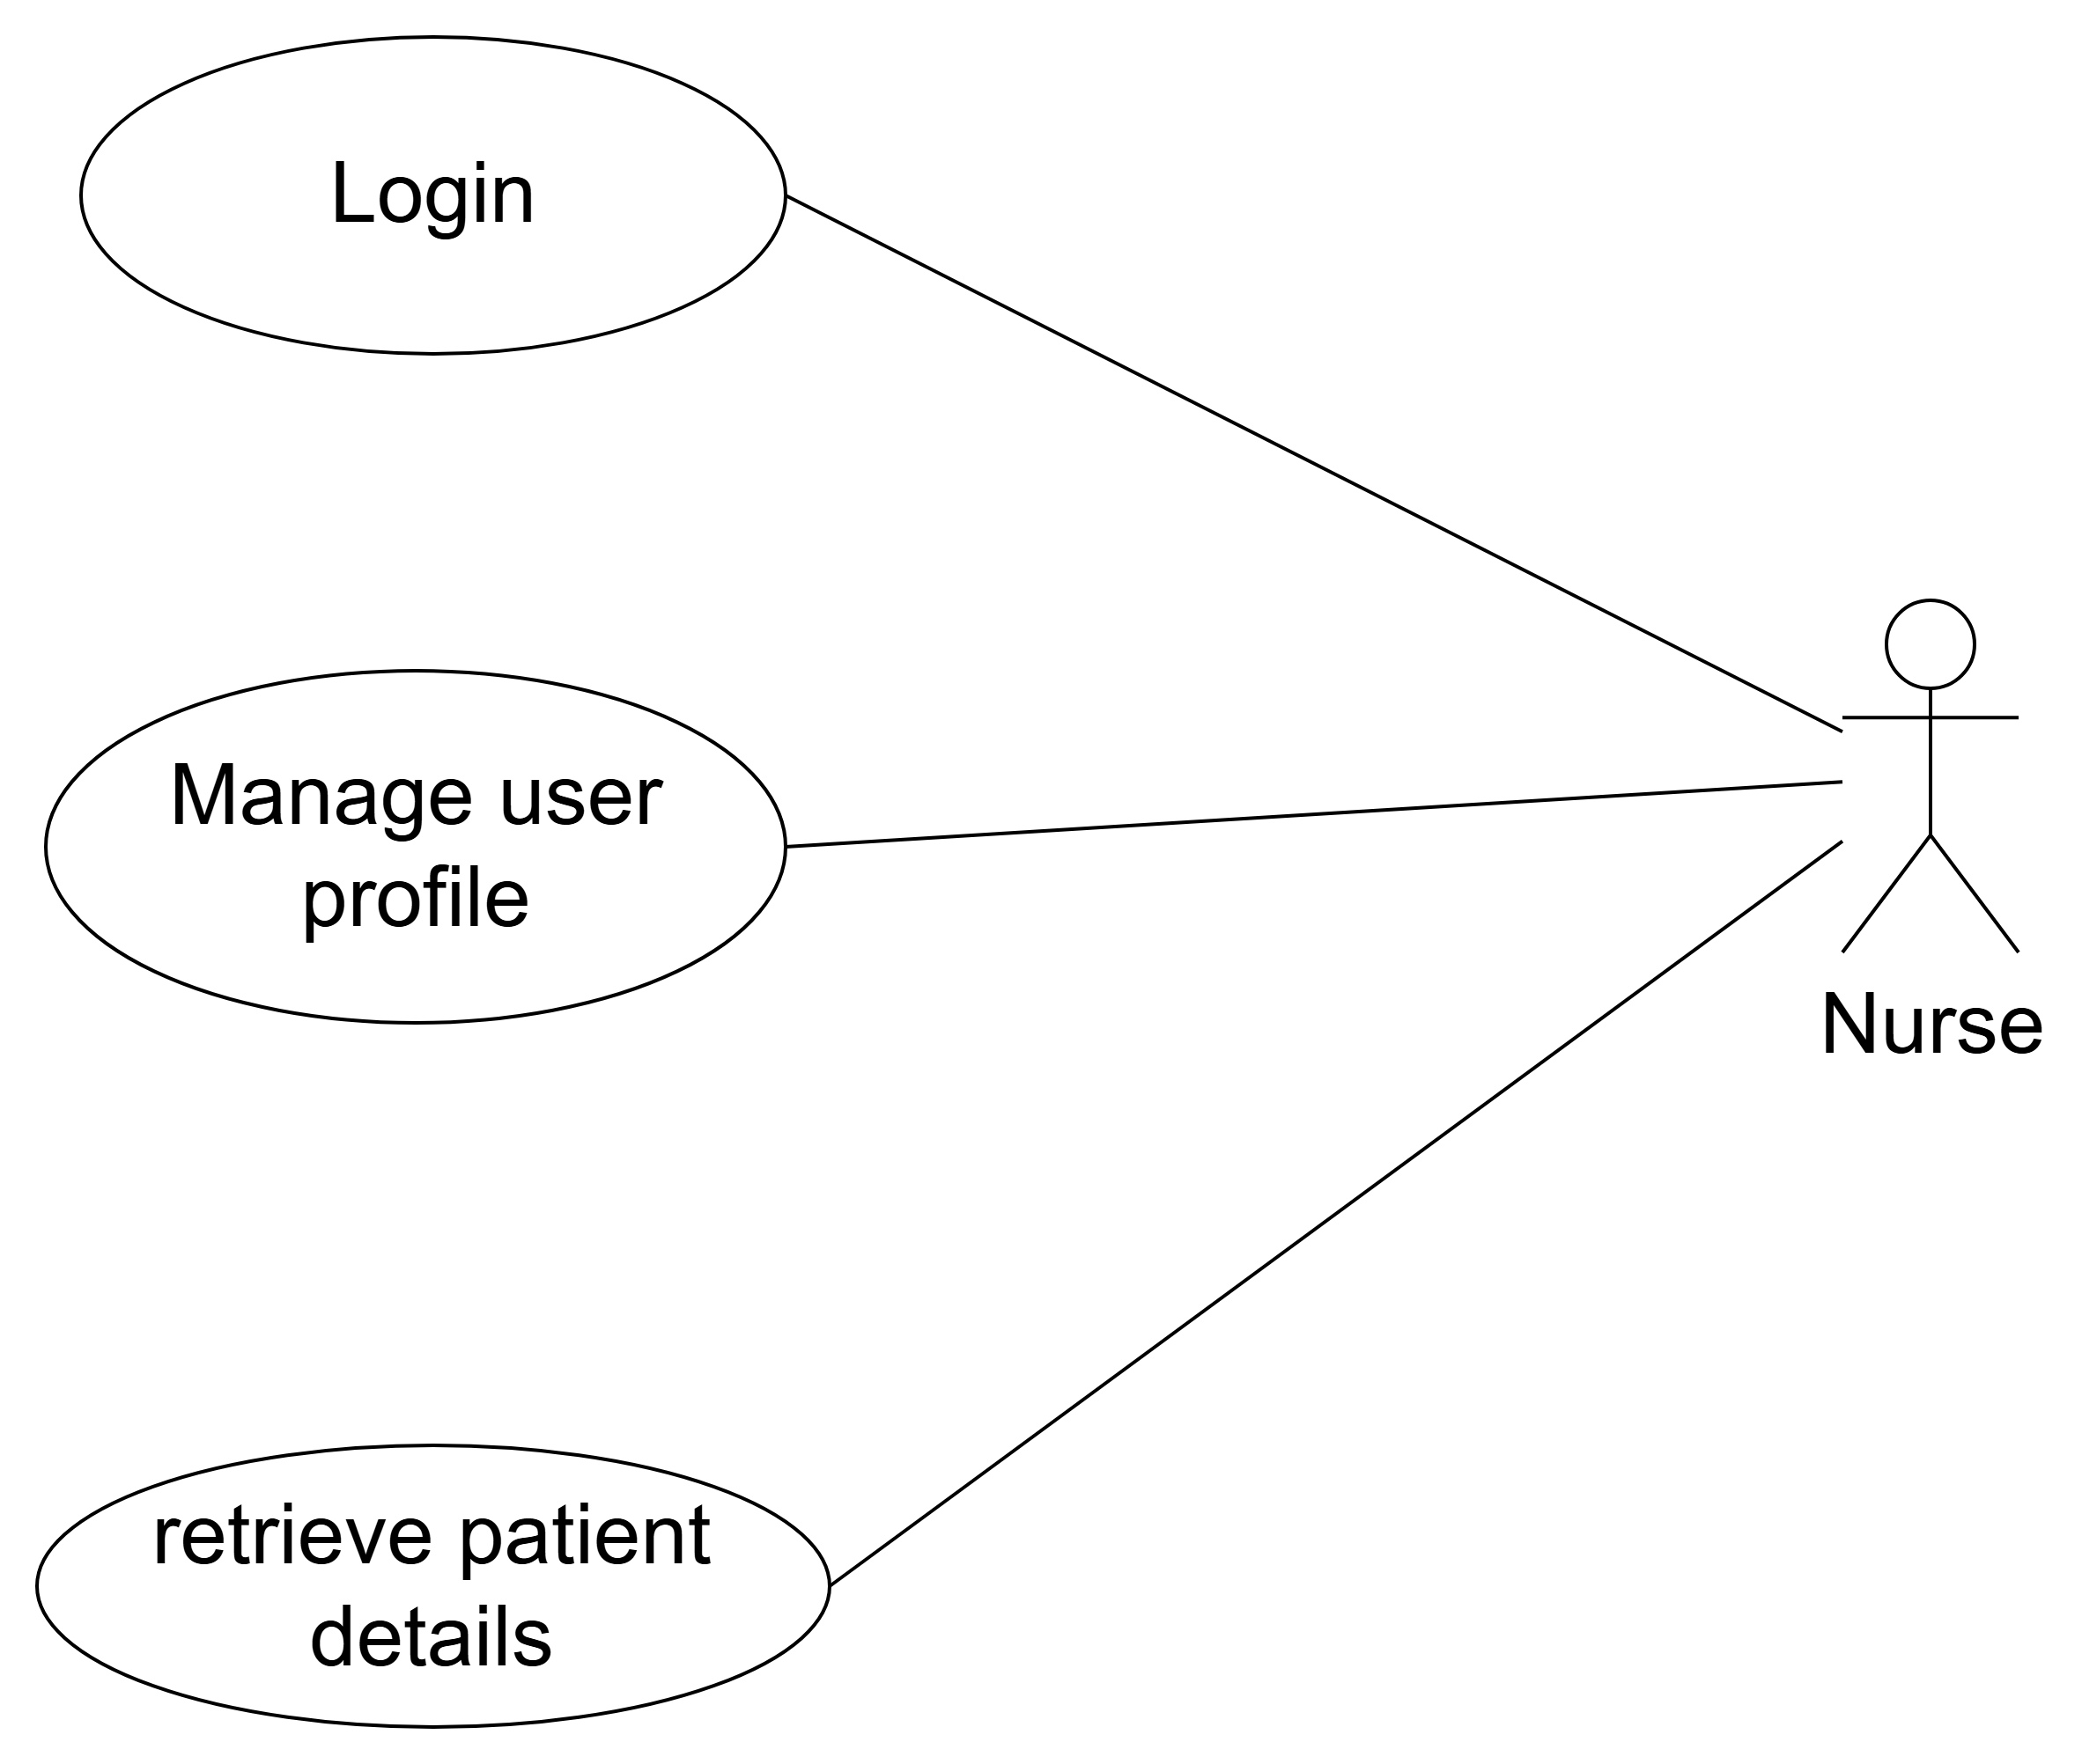

**Use-case for Nurse module**

## The Use-cases specification of Nurse Module

**1. Usecase Login**

|  |  |
| --- | --- |
| **Use Case Name** | **Login** |
| **Actor(s)** | Nurse |
| **Description** | Nurse logs into the system using the credential information. |
| **Precondition(s)** | - Nurse has valid credentials information. - The system is online  - authentication service is available.  - Network connectivity is stable |
| **Trigger** | The Nurse selects "Login." in the application interface. |
| **Main Flow** | 1. The system prompts the Nurse to enter their username and password. 2. The Nurse enters valid credentials and submits the login request. 3. The system securely sends these credentials to the authentication service. 4. authentication service verifies the credentials and confirms authenticity. 5. Upon successful verification, the system creates an authenticated user session. 6. The Nurse gains access to the system functionalities. |
| **Alternate Flow(s)** | **Invalid credentials:** 4. The system shows an error message  5. The Nurse can retry logging |
| **Postcondition(s)** | - The Nurse is authenticated, and a secure session is established. - The Nurse has access to permitted features according to their role and permissions. |
| **Exceptions** | - Network errors or connection instability preventing credential verification. - Authentication service downtime. - System errors preventing login completion. - Unexpected errors causing session management failure. |

**2. Usecase Manage User Profile**

|  |  |
| --- | --- |
| **Use Case Name** | **Manage User Profile** |
| **Actor(s)** | Nurse |
| **Description** | The Nurse can view and update personal information, including name, email, and contact details. |
| **Precondition(s)** | - The Nurse must be logged into the system. - The system verifies the user's permissions to manage their profile. |
| **Trigger** | The Nurse selects the "Profile" section from the application interface. |
| **Main Flow** | 1. The system retrieves and displays the Nurse’s current profile details. 2. The Nurse’s edits the profile information and submits changes. 3. The system validates the input data. 4. Upon successful validation, the system saves the profile updates. 5. The system displays a confirmation message indicating successful update. |
| **Alternate Flow(s)** | **Invalid data entered:** 1. The system identifies and highlights specific input fields with invalid or incomplete data. 2. The system displays clear error messages describing the validation issues. 3. The Nurse corrects the indicated errors. 4. The Nurse resubmits the updates, returning to step 2 of the main flow. |
| **Postcondition(s)** | - The Nurse’s profile is successfully updated in the system. |
| **Exceptions** | - Network connectivity issues or system errors could prevent updates, prompting an error message. - In case of persistent errors or system failures, the update is not saved, and the Doctor is notified accordingly. |

**3. Usecase Retrieve Patient Details**

|  |  |
| --- | --- |
| **Use Case Name** | **Retrieve Patient Details** |
| **Actor(s)** | Nurse |
| **Description** | The Nurse retrieves and views comprehensive details about a patient, including personal information, medical history, appointments, prescriptions, and treatment notes. |
| **Precondition(s)** | - Nurse must be logged into the HMS. - Nurse must have valid authorization and permissions to view patient information. - Patient data must exist in the HMS database. |
| **Trigger** | Doctor selects "View Patient Details" or searches for a patient in the HMS interface. |
| **Main Flow** | 1. The system displays a search interface to locate the patient by name, patient ID, or appointment schedule. 2. Nurse inputs search criteria and submits. 3. System retrieves matching patient records and displays search results. 4. Nurse selects the patient from the displayed results. 5. System presents comprehensive patient details, including personal information, medical history, current prescriptions, appointments, treatment history, allergies, and other clinical notes. 6. Nurse reviews the patient details as needed. |
| **Alternate Flow(s)** | **Patient record not found:** 1. System displays a clear notification indicating no patient matches found. 2. Nurse modifies search criteria and attempts the search again (returning to step 2). |
| **Postcondition(s)** | - Patient details are successfully retrieved and displayed to the authorized doctor. - No changes are made to patient data from viewing. - Retrieval activity is logged in the HMS audit records for security purposes. |
| **Exceptions** | - Network issues or system errors preventing retrieval of patient details. - Database or server downtime resulting in data unavailability. - Unauthorized access attempt detected and blocked by the system. |

**Use-case for Administrator module**

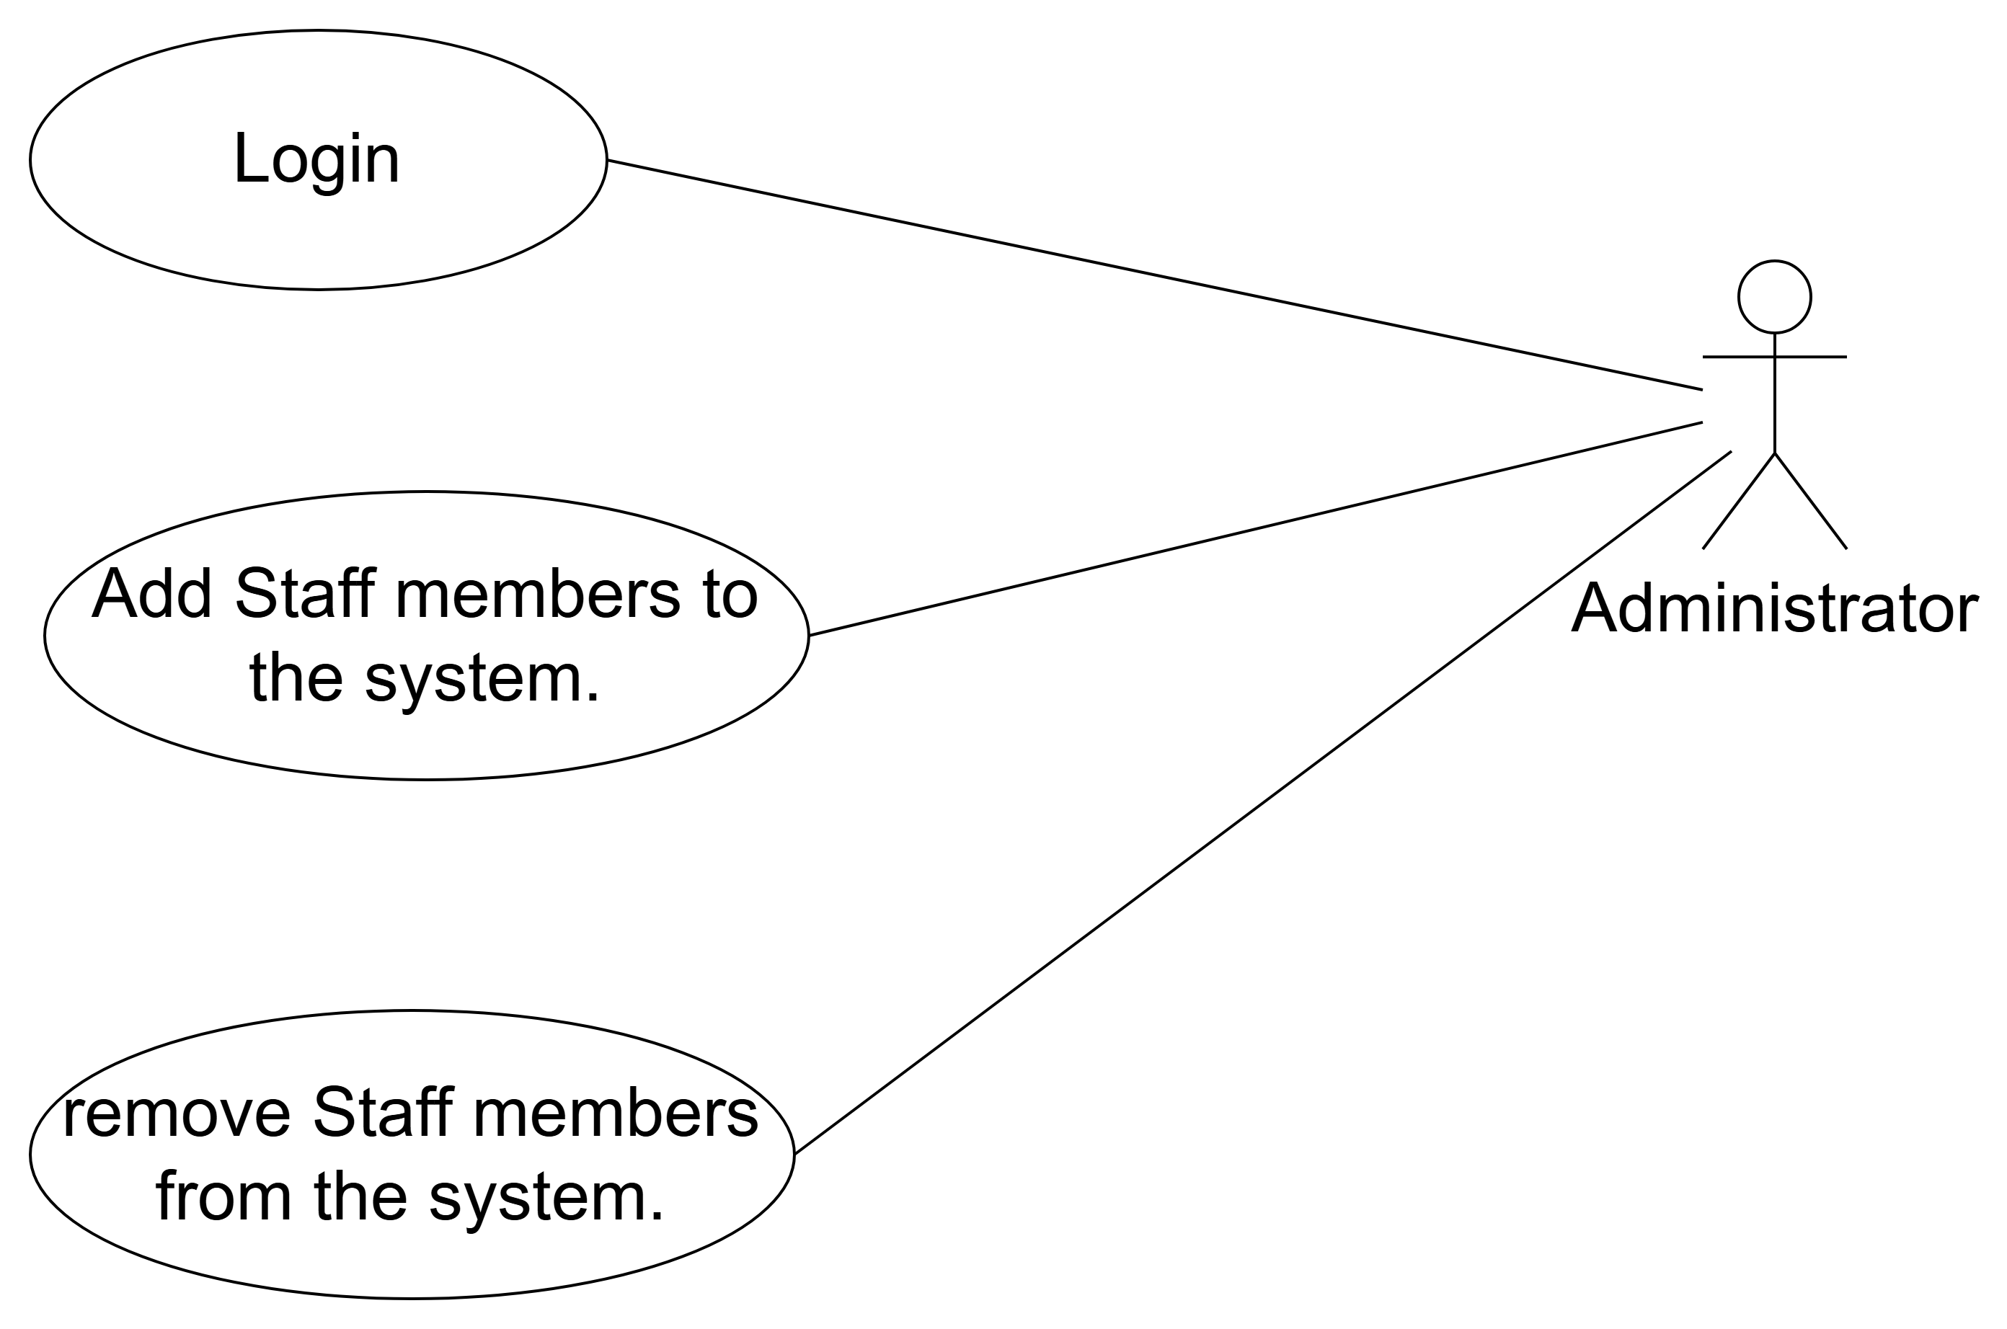

**Use-case for Administrator module**

## The Use-cases specification of **Aministrator Module**

**1. Usecase Login**

|  |  |
| --- | --- |
| **Use Case Name** | **Login** |
| **Actor(s)** | Aministrator |
| **Description** | Aministrator logs into the system using the credential information. |
| **Precondition(s)** | - Aministrator has valid credentials information. - The system is online  - authentication service is available.  - Network connectivity is stable |
| **Trigger** | The Aministrator selects "Login." in the application interface. |
| **Main Flow** | 1. The system prompts the Aministrator to enter their username and password. 2. The Aministrator enters valid credentials and submits the login request. 3. The system securely sends these credentials to the authentication service. 4. authentication service verifies the credentials and confirms authenticity. 5. Upon successful verification, the system creates an authenticated user session. 6. The Aministrator gains access to the system functionalities. |
| **Alternate Flow(s)** | **Invalid credentials:** 4. The system shows an error message  5. The Aministrator can retry logging |
| **Postcondition(s)** | - The Aministrator is authenticated, and a secure session is established. - The Aministrator has access to permitted features according to their role and permissions. |
| **Exceptions** | - Network errors or connection instability preventing credential verification. - Authentication service downtime. - System errors preventing login completion. - Unexpected errors causing session management failure. |

**2. Usecase Add staff members**

|  |  |
| --- | --- |
| **Use Case Name** | **Login** |
| **Actor(s)** | Aministrator |
| **Description** | The administrator adds a new staff member, specifically a doctor or nurse, into the HMS, including their profile details, professional information, and system permissions. |
| **Precondition(s)** | - Administrator must be logged into the HMS. - Required details about the new staff member are available. |
| **Trigger** | Administrator selects "Add Staff Member" within the Staff Management module in HMS. |
| **Main Flow** | 1. The system displays a form to input new staff member details (e.g., full name, position (doctor/nurse), specialty, contact information, credentials, schedule availability, and username/password). 2. Administrator enters staff member details and assigns appropriate permissions and roles. 3. Administrator submits the completed form. 4. The system validates the entered information for completeness, accuracy, and uniqueness (e.g., username, employee ID). 5. Upon successful validation, the system creates the staff member’s account and saves their information securely in the database. 6. Administrator receives confirmation that the new staff member has been successfully added. |
| **Alternate Flow(s)** | **Incomplete or Invalid Information:** 1. System highlights missing or invalid fields and prompts the administrator to correct the errors. 2. Administrator corrects the identified fields and resubmits the form (returns to step 4 of the main flow).  **Duplicate Username or Employee ID:** 1. System alerts the administrator of the duplicate information. 2. Administrator modifies the details accordingly and resubmits (returns to step 4). |
| **Postcondition(s)** | - New staff member's account (doctor or nurse) is successfully created in HMS. - Staff member can now log into HMS with assigned credentials. - Administrator receives confirmation notification. - The action is recorded in the HMS audit logs for administrative tracking. |
| **Exceptions** | - System or database errors preventing successful account creation. - Network issues disrupting information submission or validation. - Persistent validation issues preventing the addition of the staff member. |

**3. Usecase remove staff members**

|  |  |
| --- | --- |
| **Use Case Name** | **Login** |
| **Actor(s)** | Aministrator |
| **Description** | The administrator removes an existing staff member (doctor or nurse) from the HMS, revoking their access and archiving their data as necessary. |
| **Precondition(s)** | - Administrator must be logged into the HMS. - Staff member (doctor/nurse) exists in the HMS database. |
| **Trigger** | Administrator selects "Remove Staff Member" within the Staff Management module. |
| **Main Flow** | 1. The system displays a list of current staff members (doctors/nurses). 2. Administrator selects the staff member to be removed. 3. The system prompts the administrator to confirm the removal action, clearly specifying consequences (e.g., loss of access, data archival). 4. Administrator confirms the removal. 5. The system deactivates or deletes the staff member’s HMS access and archives the associated data as required by policy. 6. Administrator receives confirmation that the staff member has been successfully removed. |
| **Alternate Flow(s)** | **Administrator Cancels Removal:** 1. Administrator cancels the removal operation at confirmation step. 2. System aborts the removal process and returns the administrator to the staff management interface. |
| **Postcondition(s)** | - Staff member’s account is removed or deactivated from HMS. - Staff member no longer has access to HMS. - Staff member’s records are archived securely per hospital guidelines. - Removal event logged in HMS audit trail for accountability purposes. |
| **Exceptions** | - System or database errors preventing staff removal. - Network disruptions causing incomplete removal process. - Administrator lacks permissions for completing removal operation. |

# 3. System modeling

## 3.1 Activity diagram to capture the business process between systems and the stakeholders

## Activity diagram to capture the business process between systems and the Patient

* **Login**

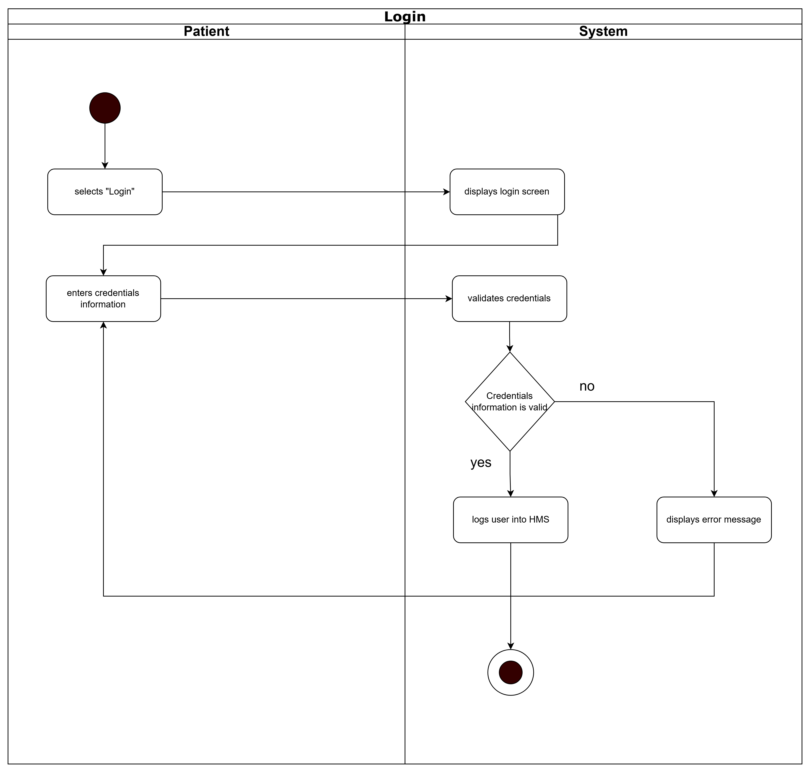

**Activity diagram for “Login”**

* **Manage User Profile**

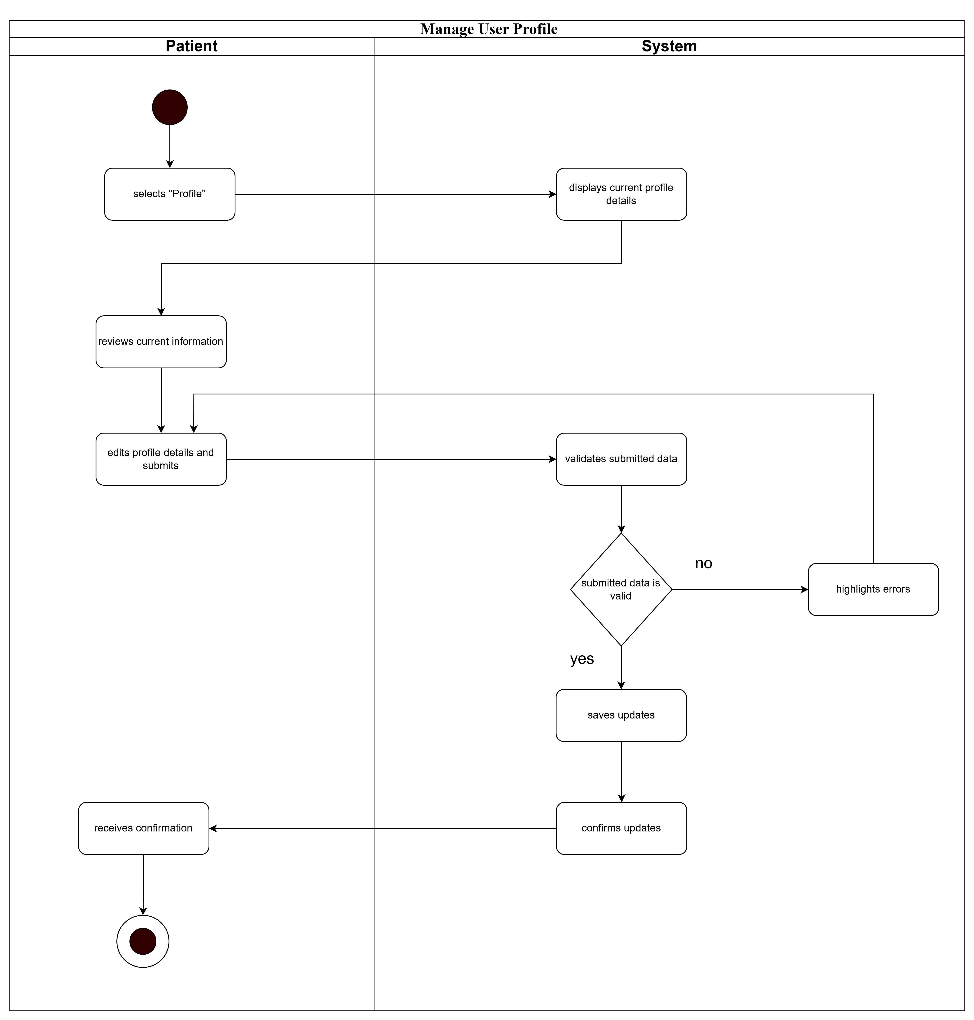

**Activity diagram for “Manage User Profile”**

* **Booking appointment with doctor**

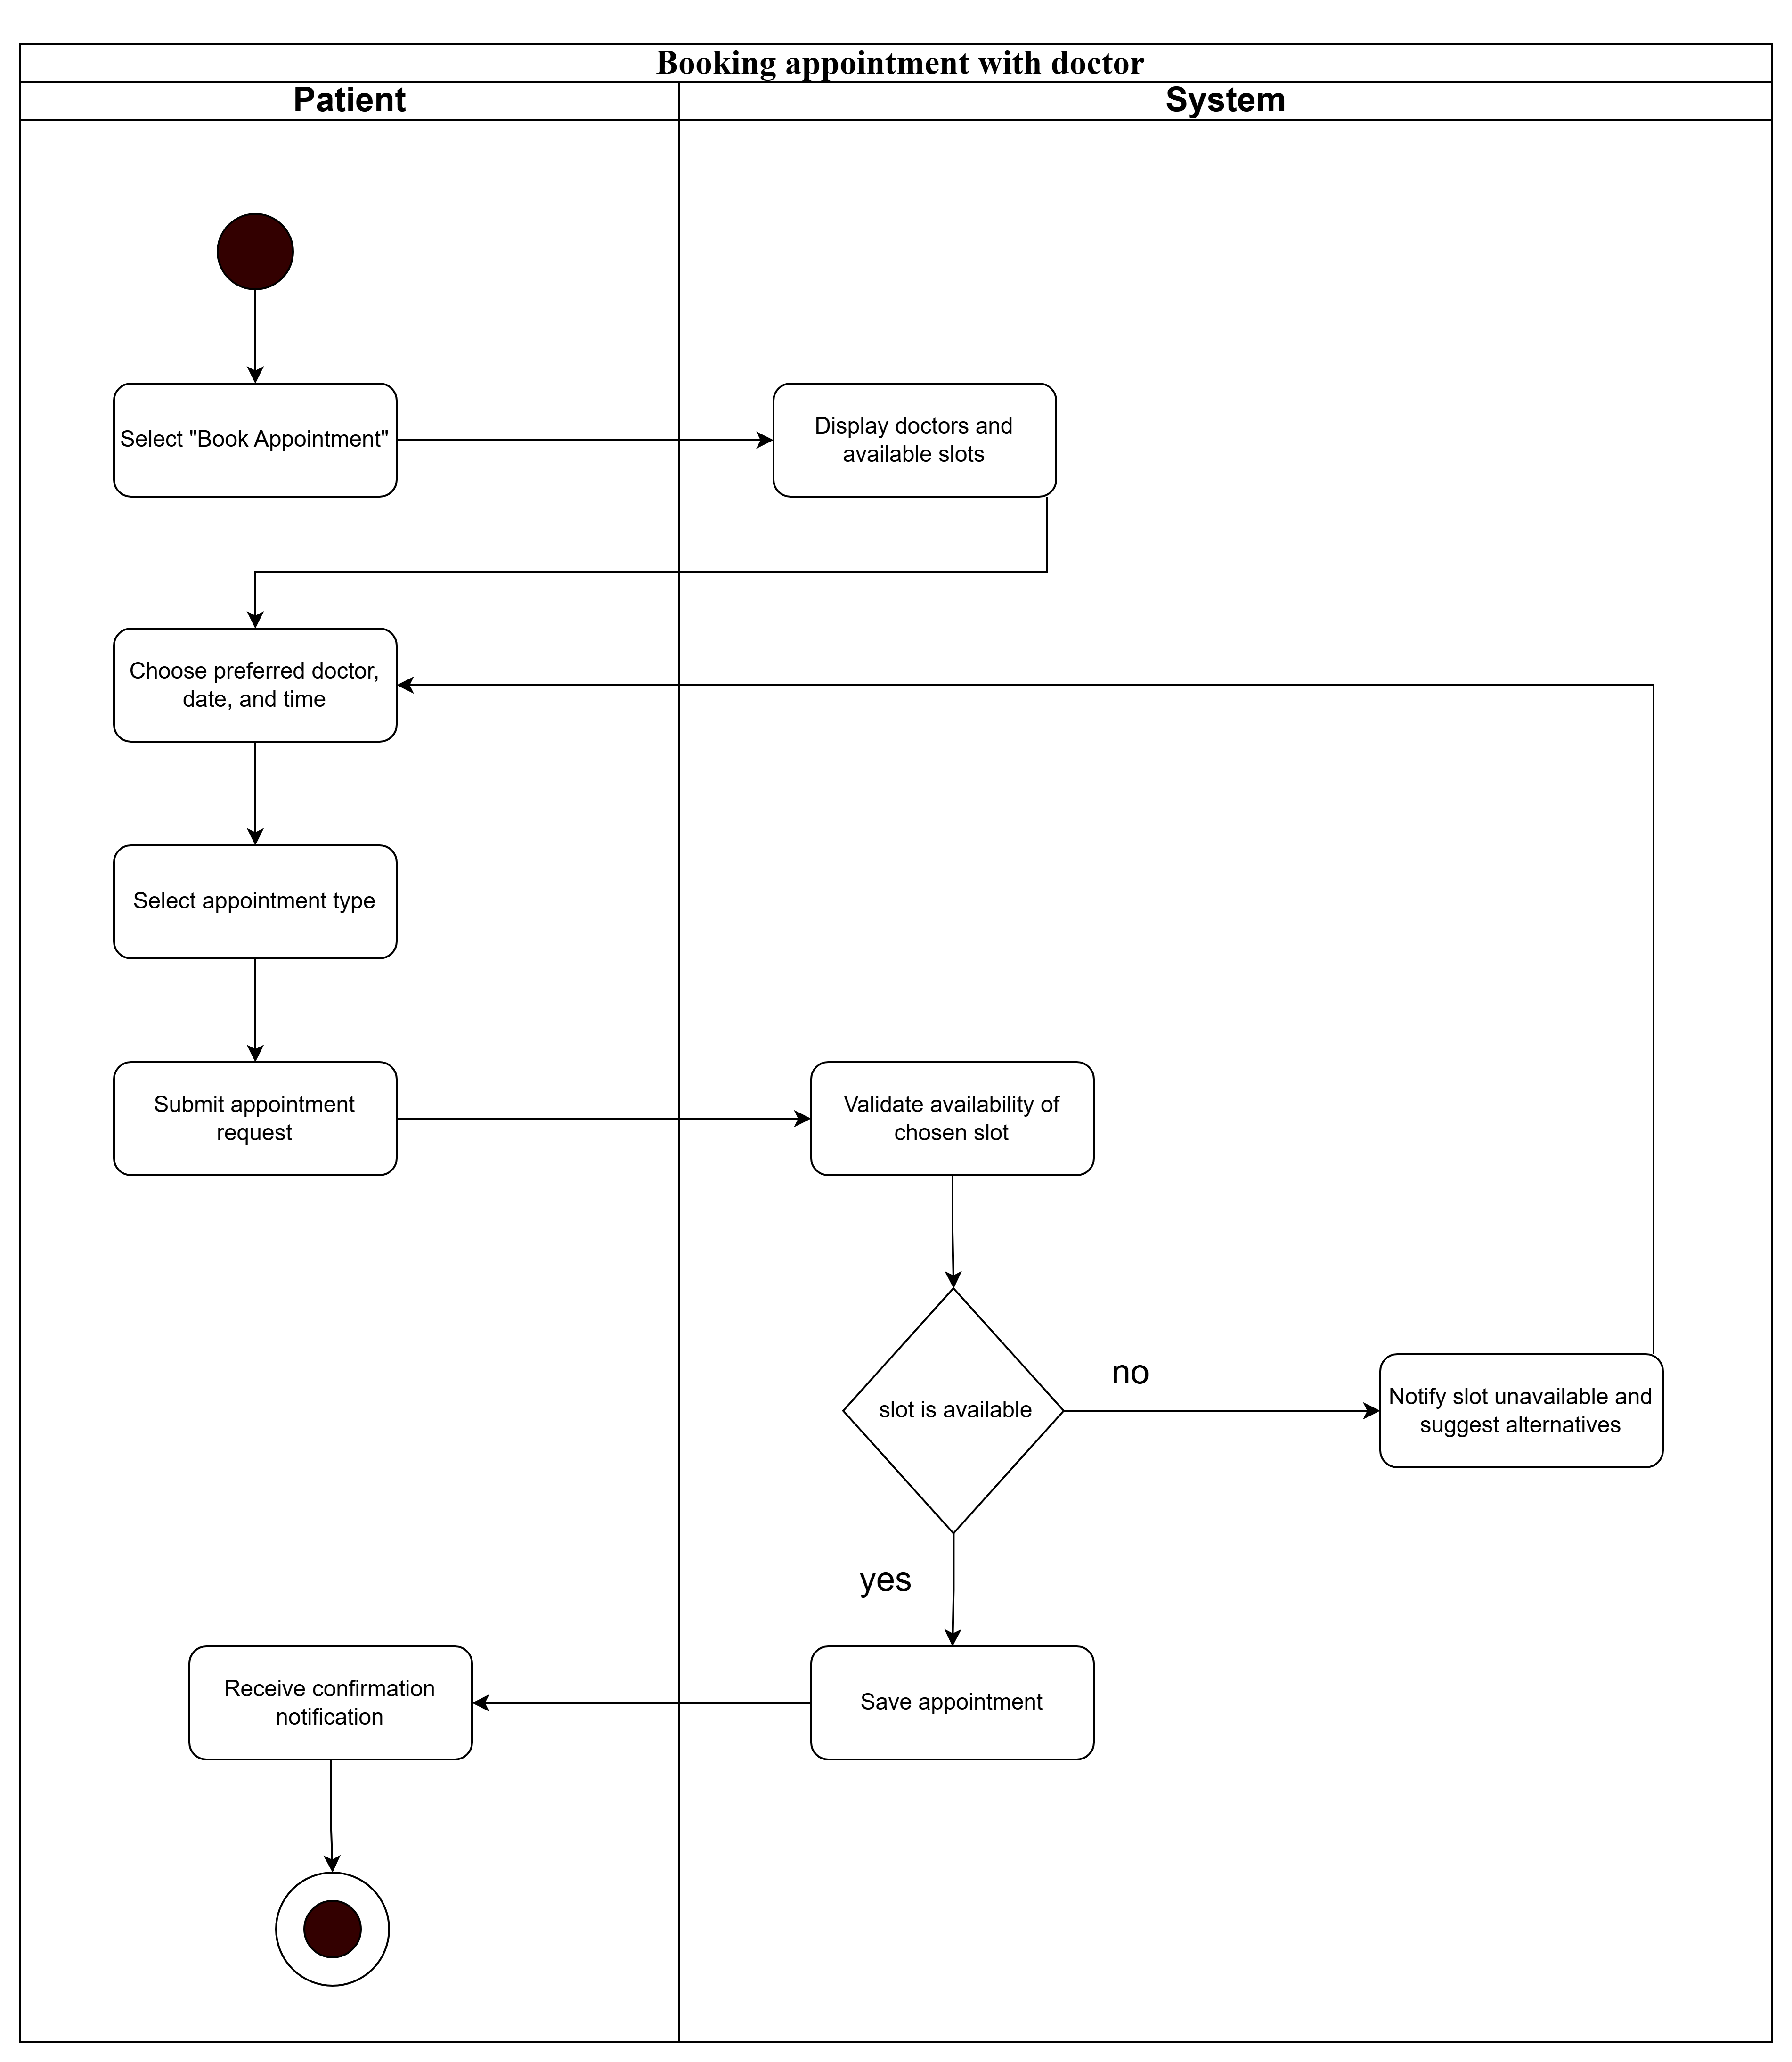

**Activity diagram for “Booking appointment with doctor”**

* **Account Registration**

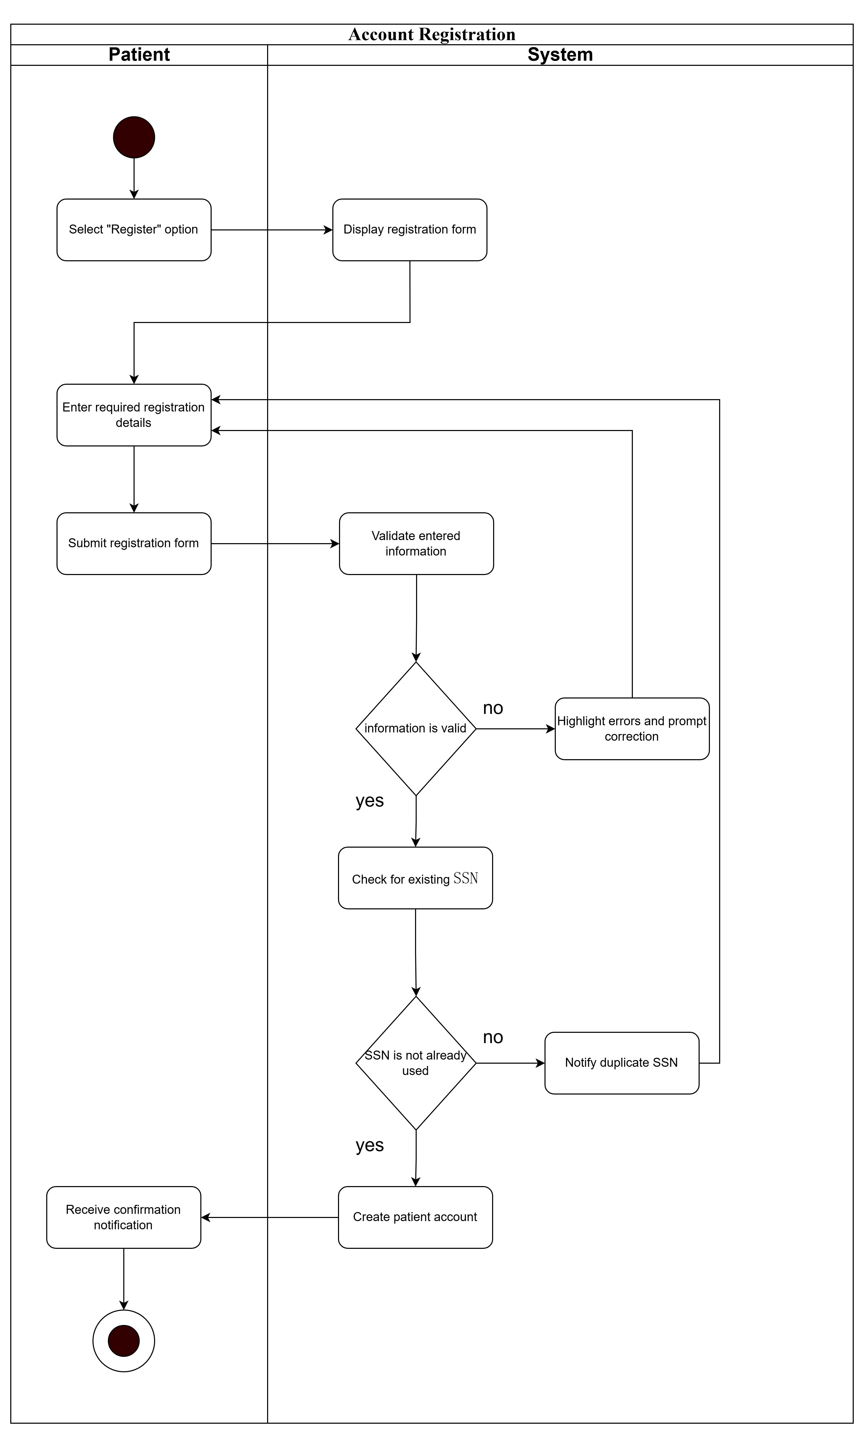

**Activity diagram for “Account Registration”**

* **View Bill Detail**

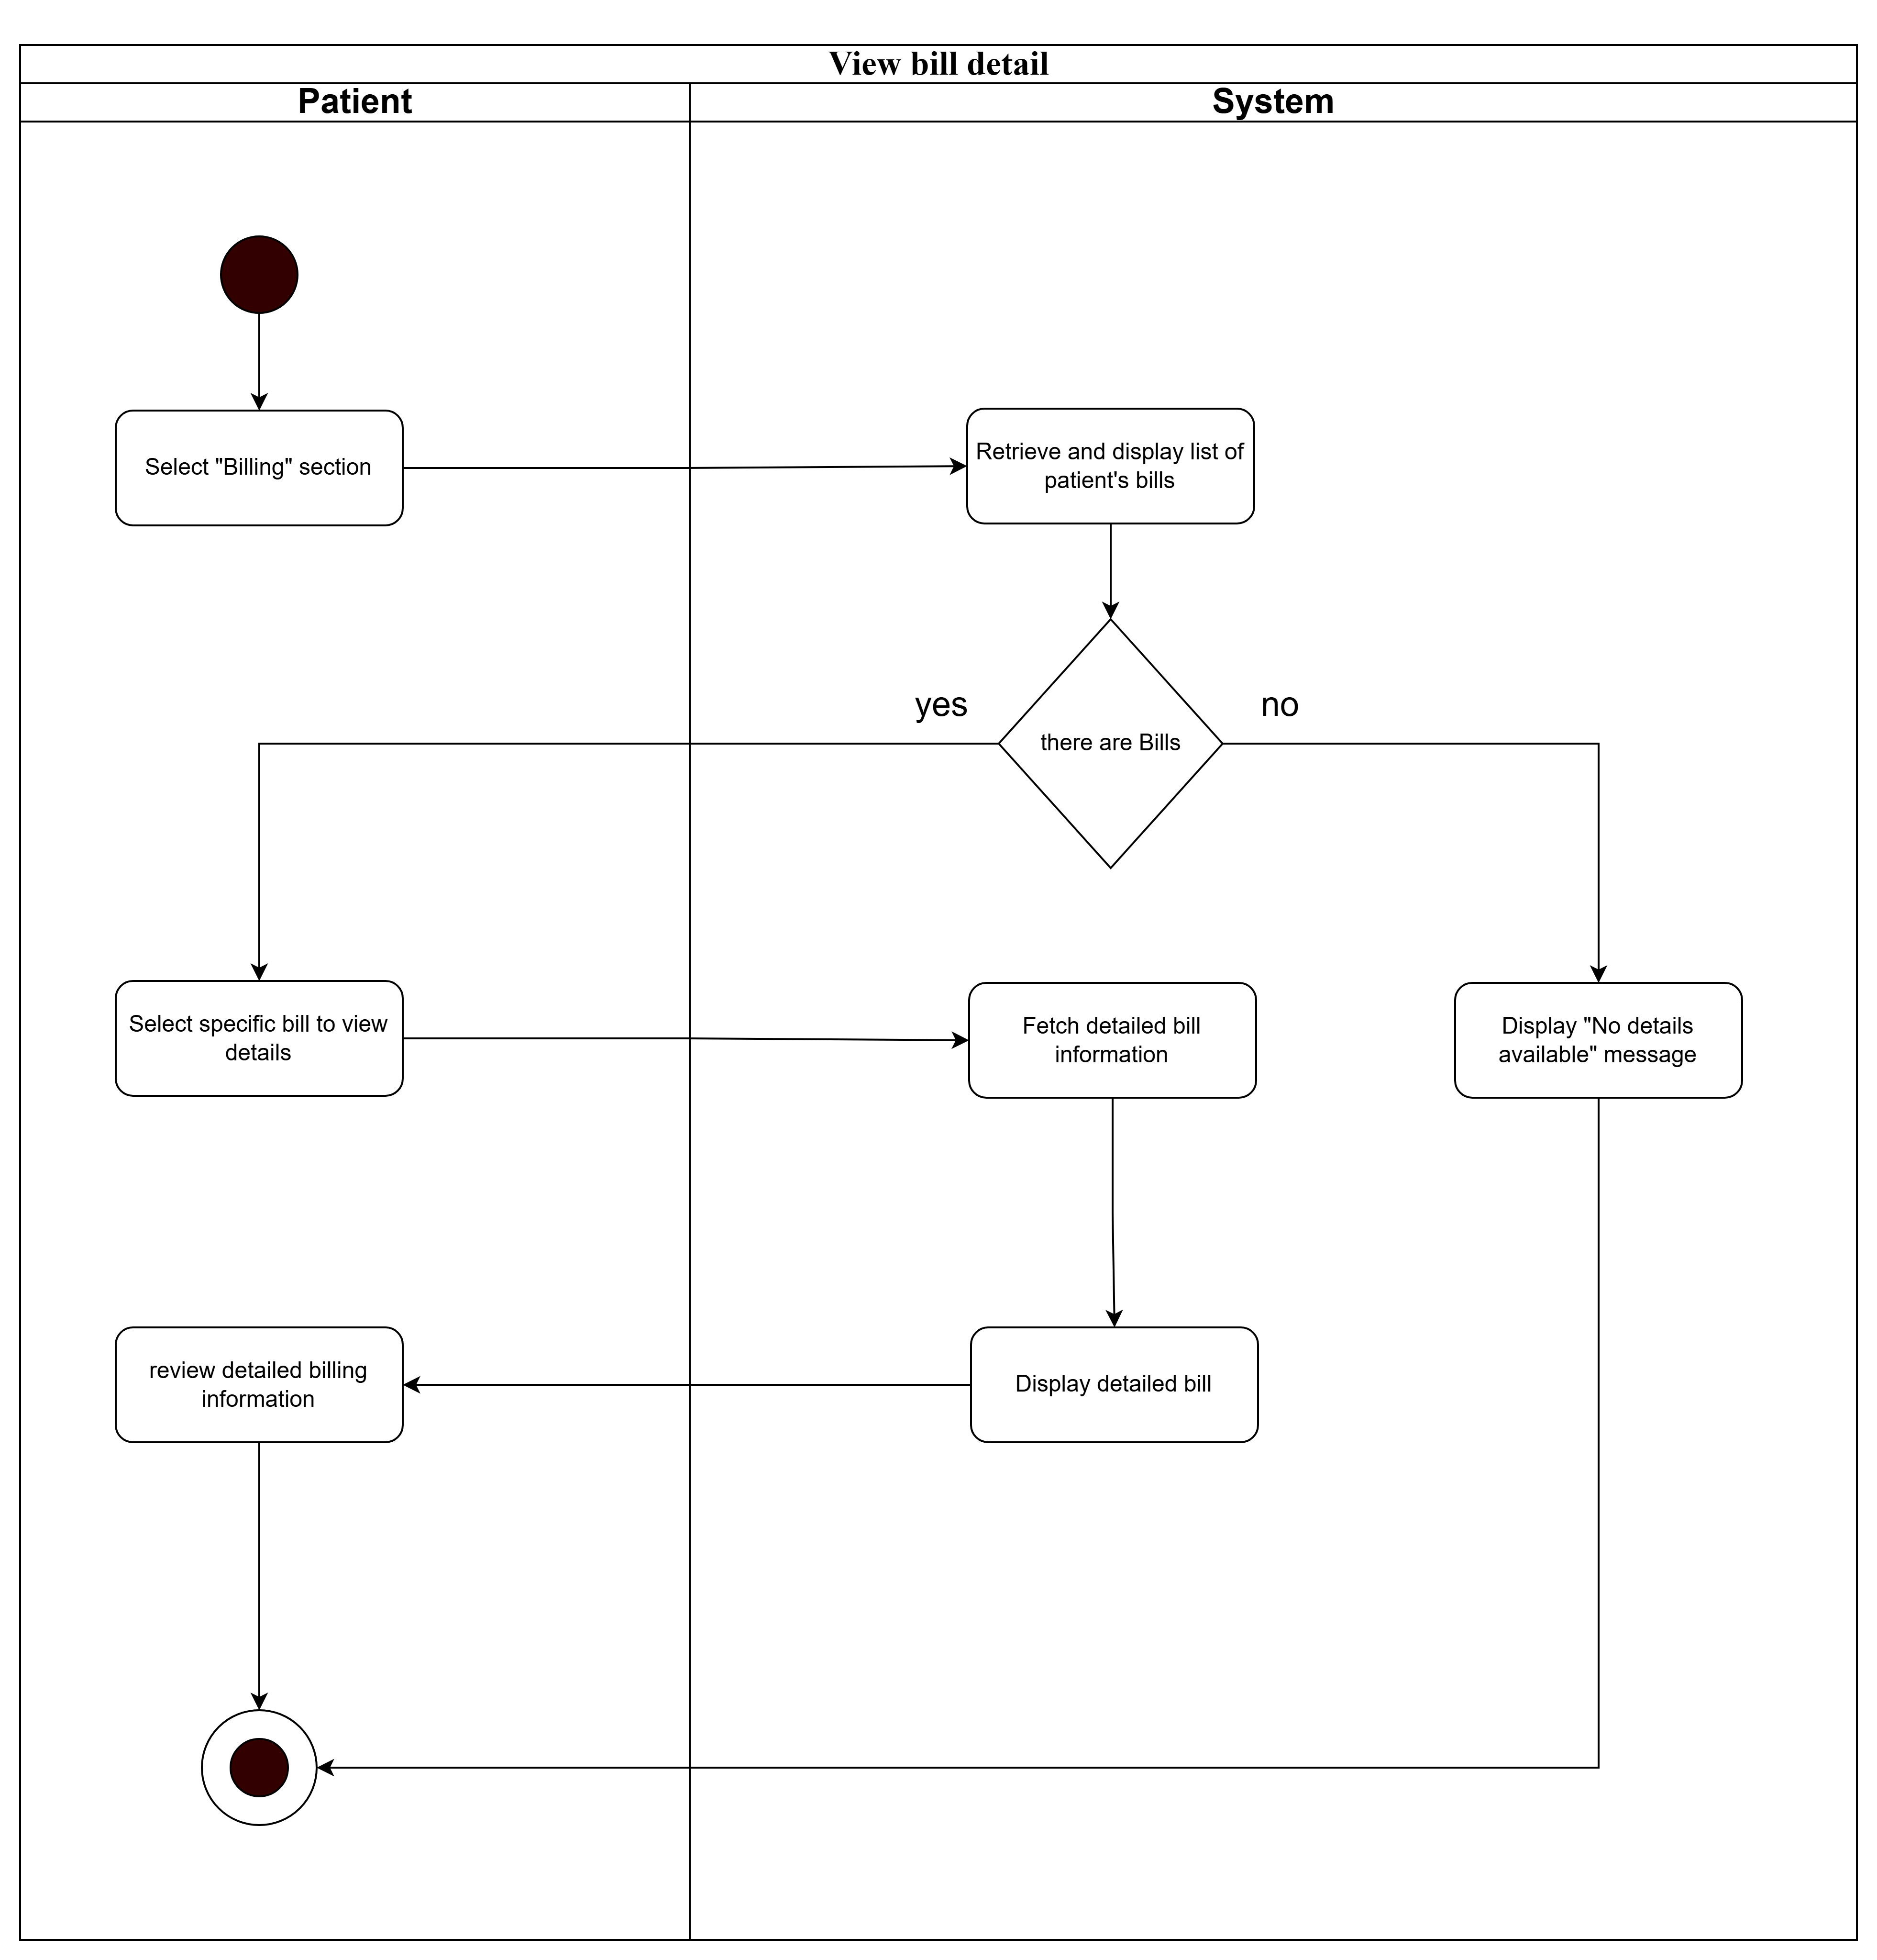

**Activity diagram for “View Bill Detail”**

* **Making payment**

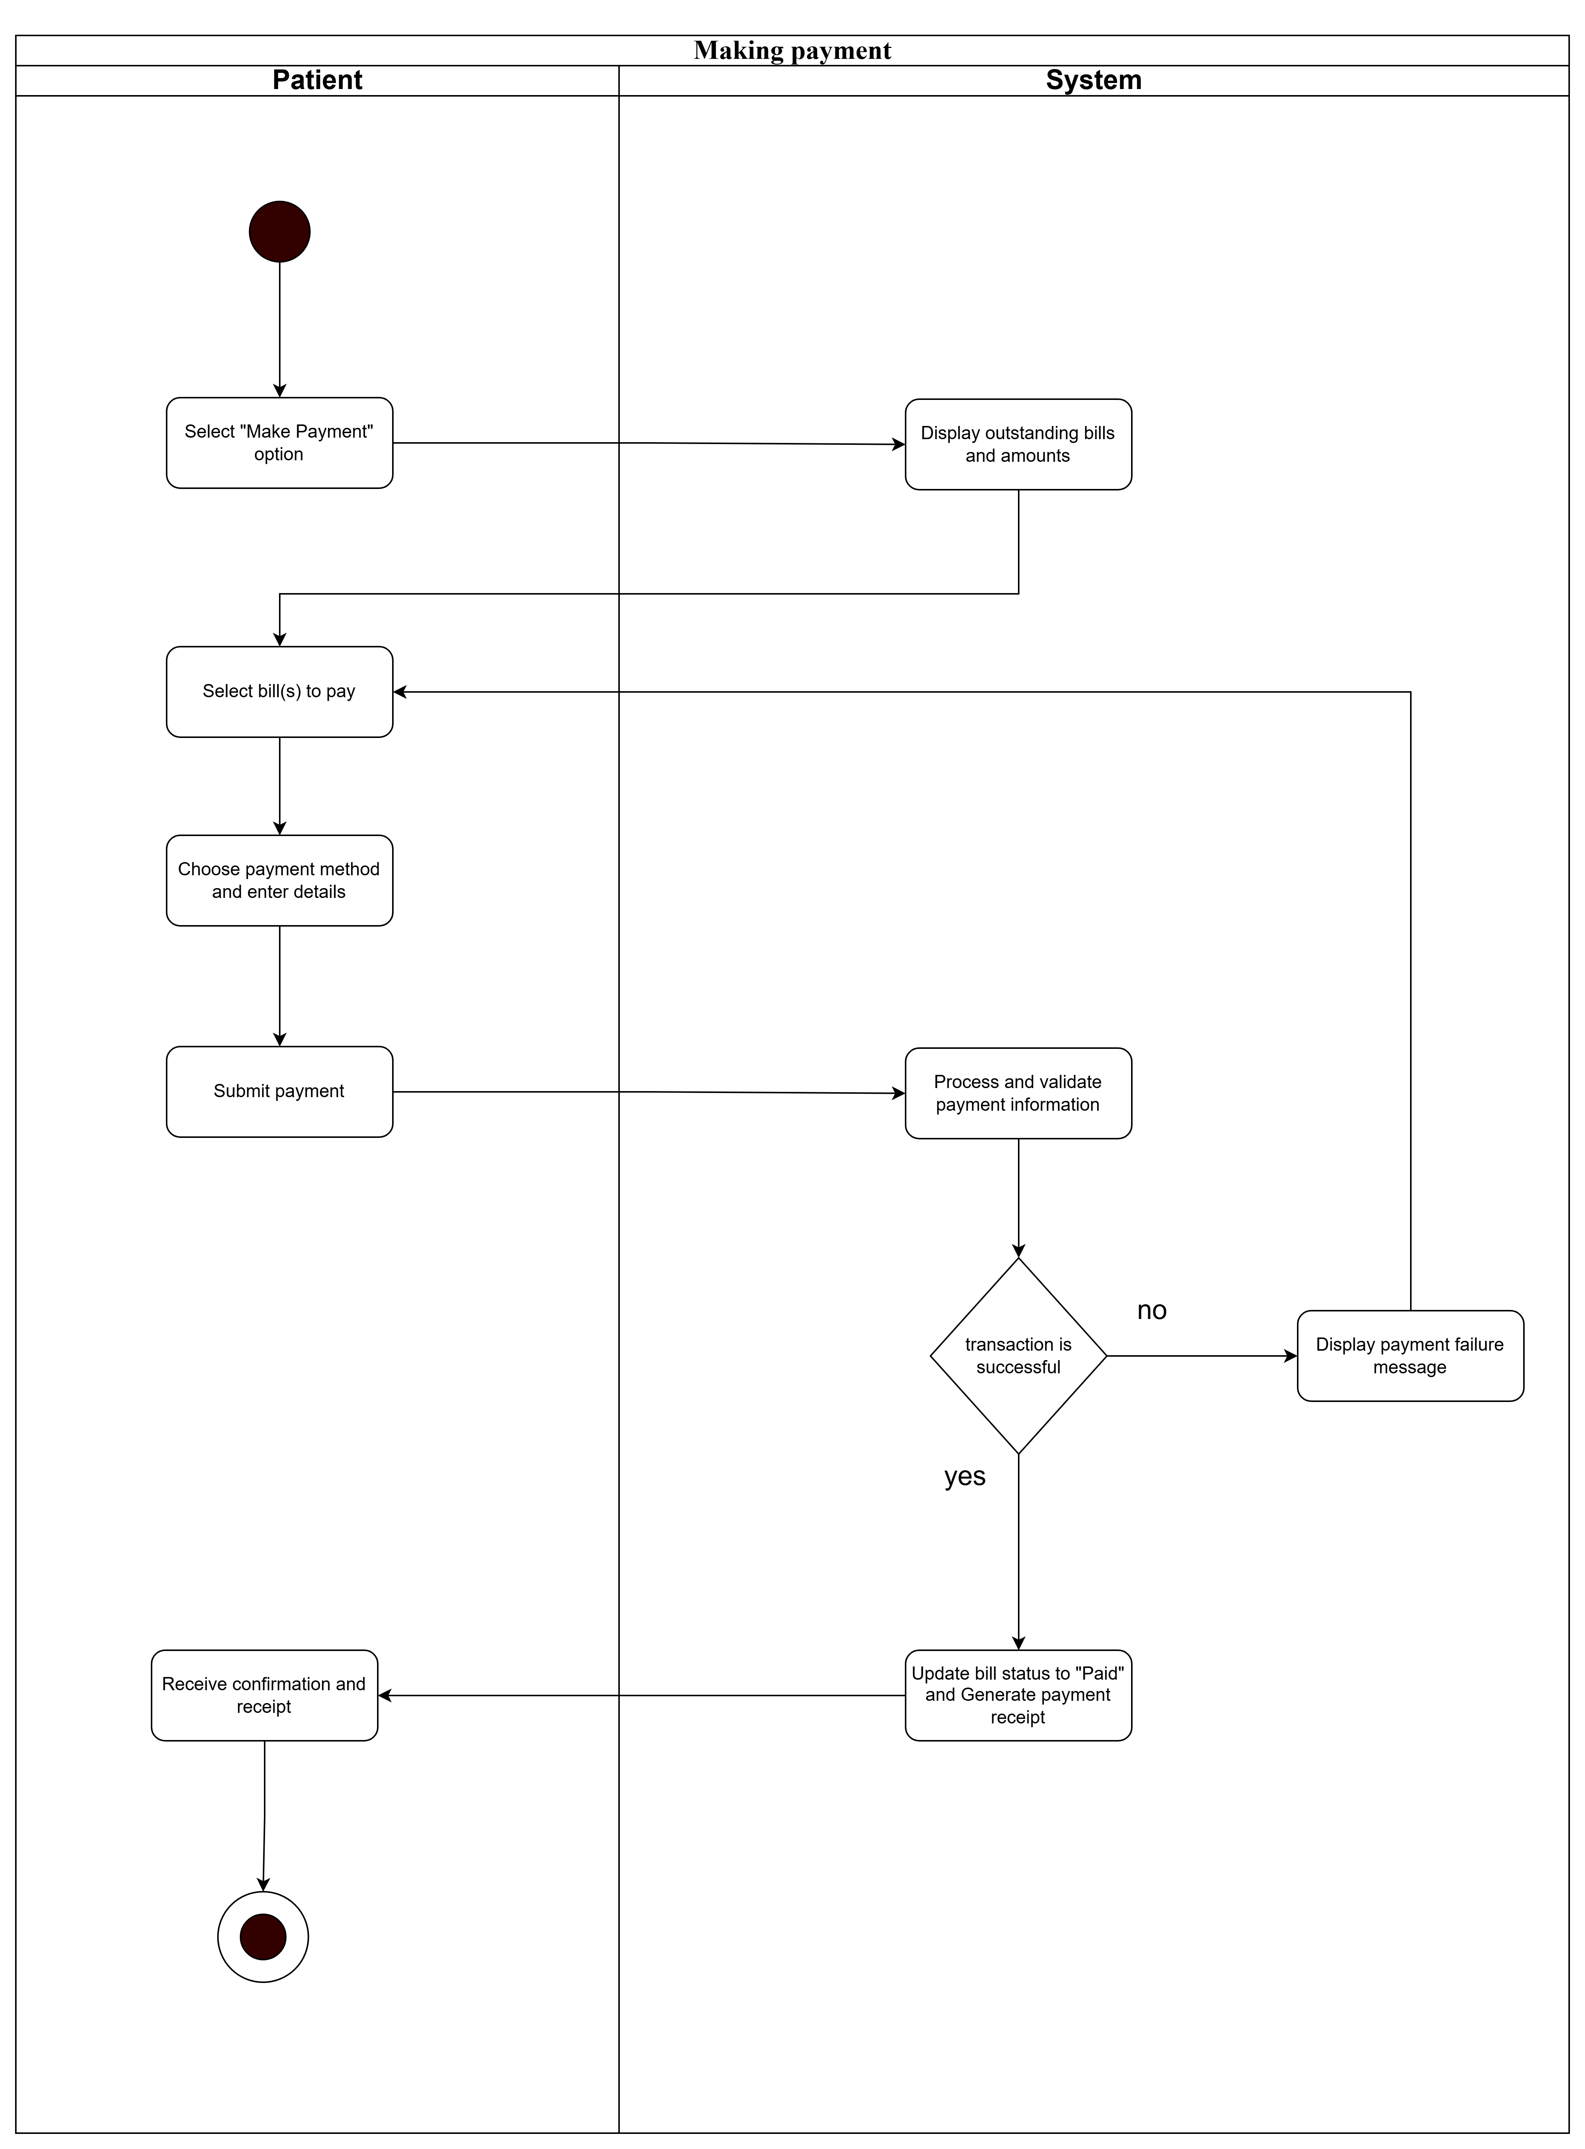

**Activity diagram for “Making payment”**

## Activity diagram to capture the business process between systems and the doctor

* **Login**

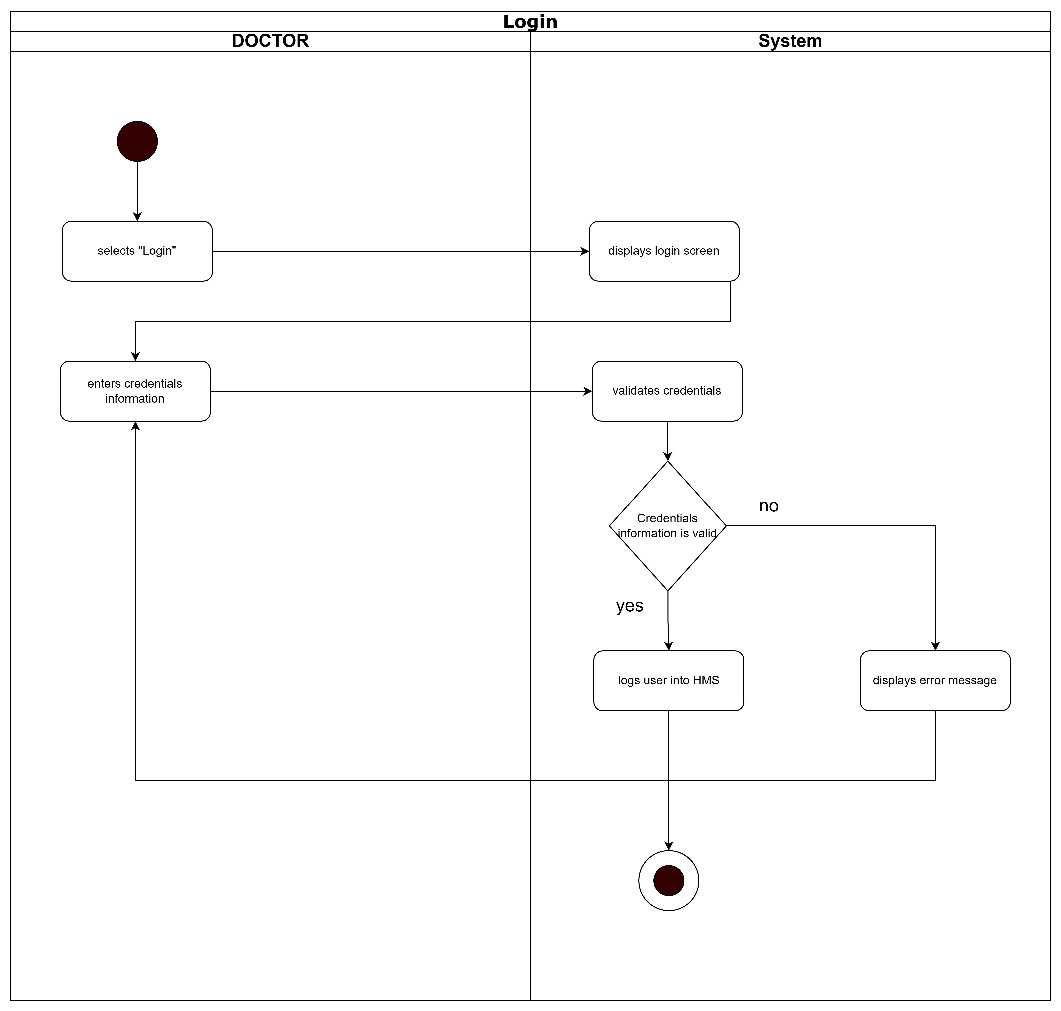

## **Activity diagram for “Login”**

* **Manage User Profile**

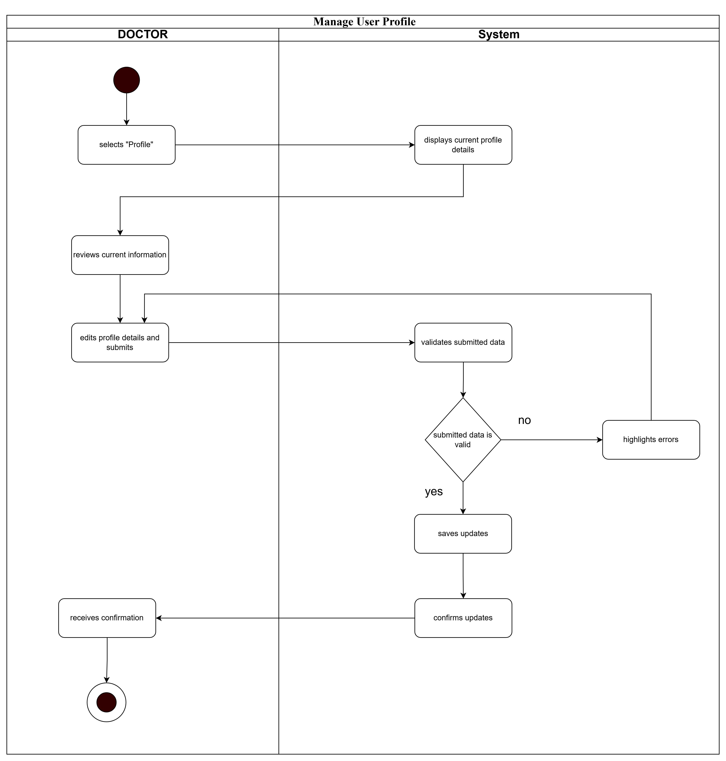

## **Activity diagram for “Manage User Profile”**

* **Retrieve Patient Details**

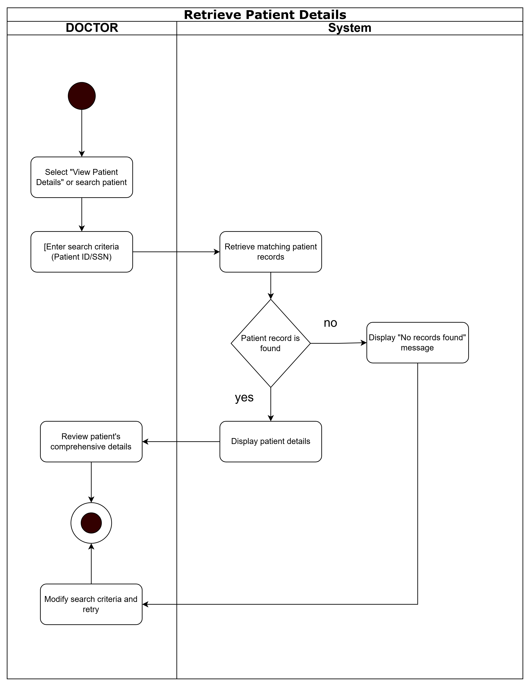

## **Activity diagram for “Manage User Profile”**

* **Update medical and health information**

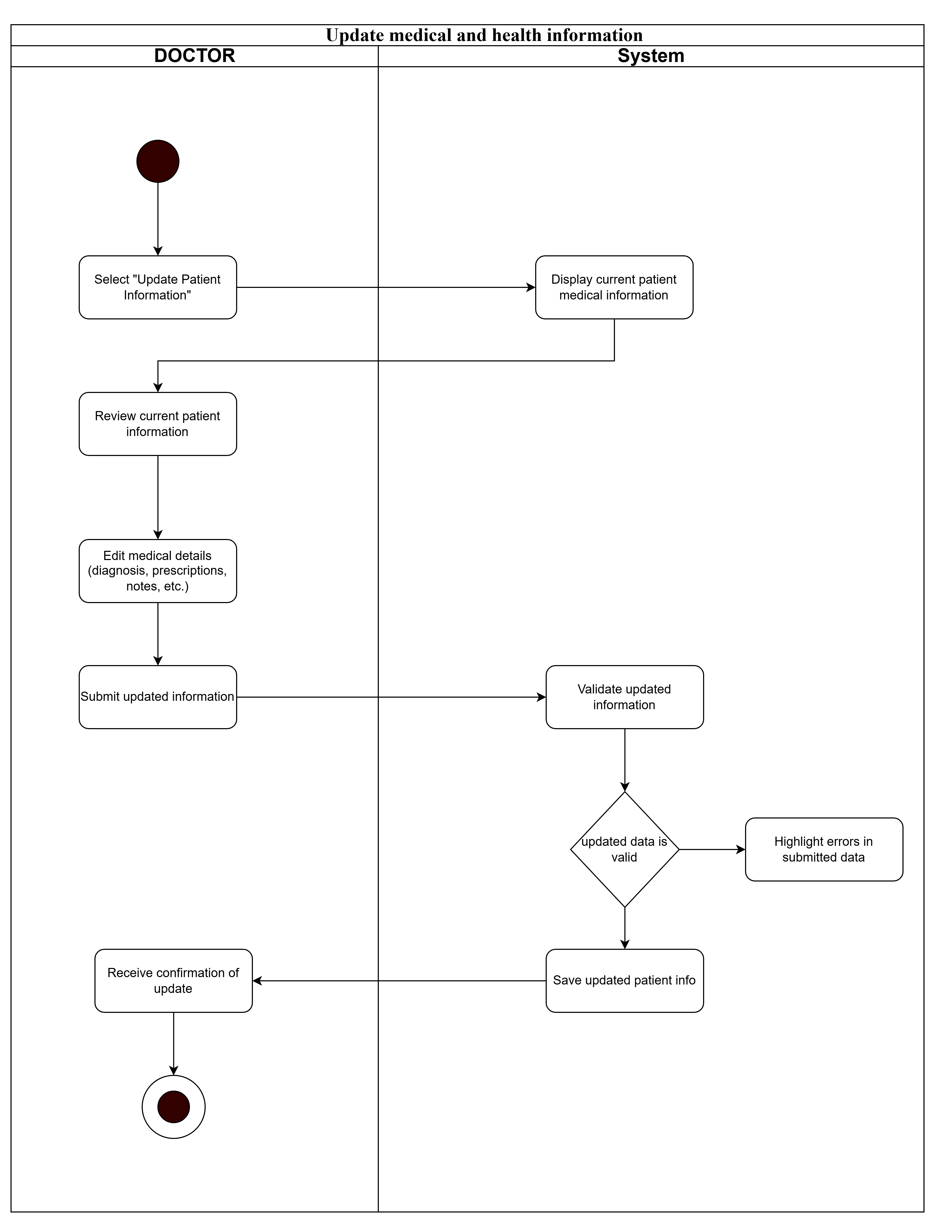

**Activity diagram for “Manage User Profile”**

## Activity diagram to capture the business process between systems and the nurse

* **Login**

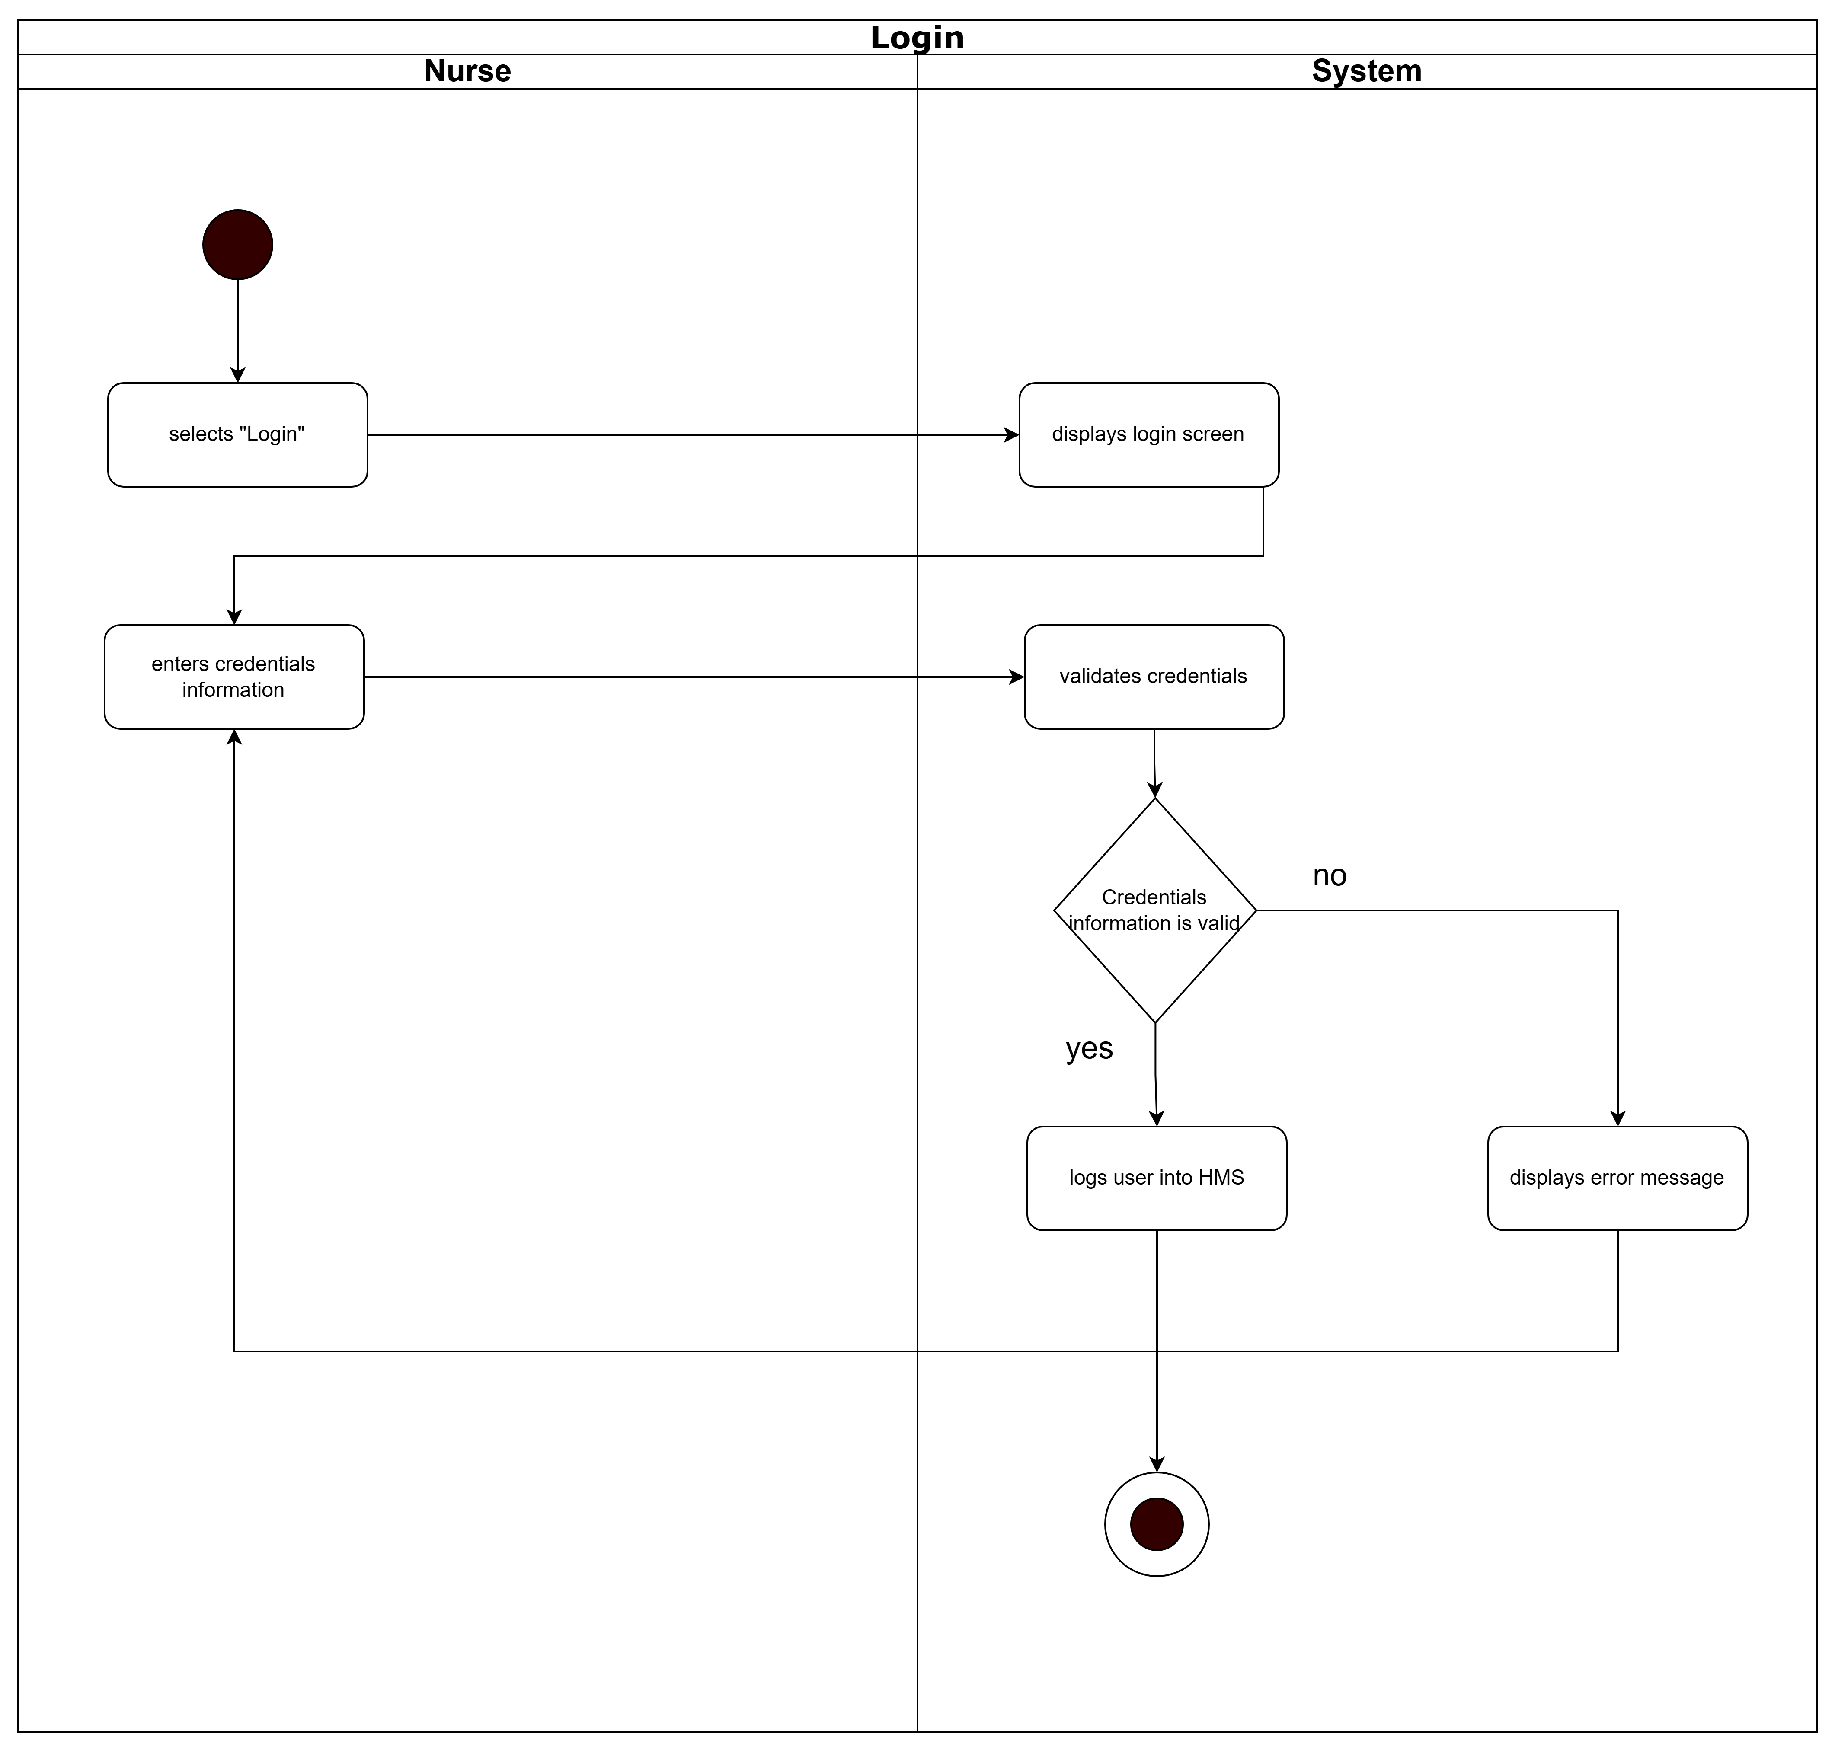

**Activity diagram for “Login”**

* **Manage User Profile**

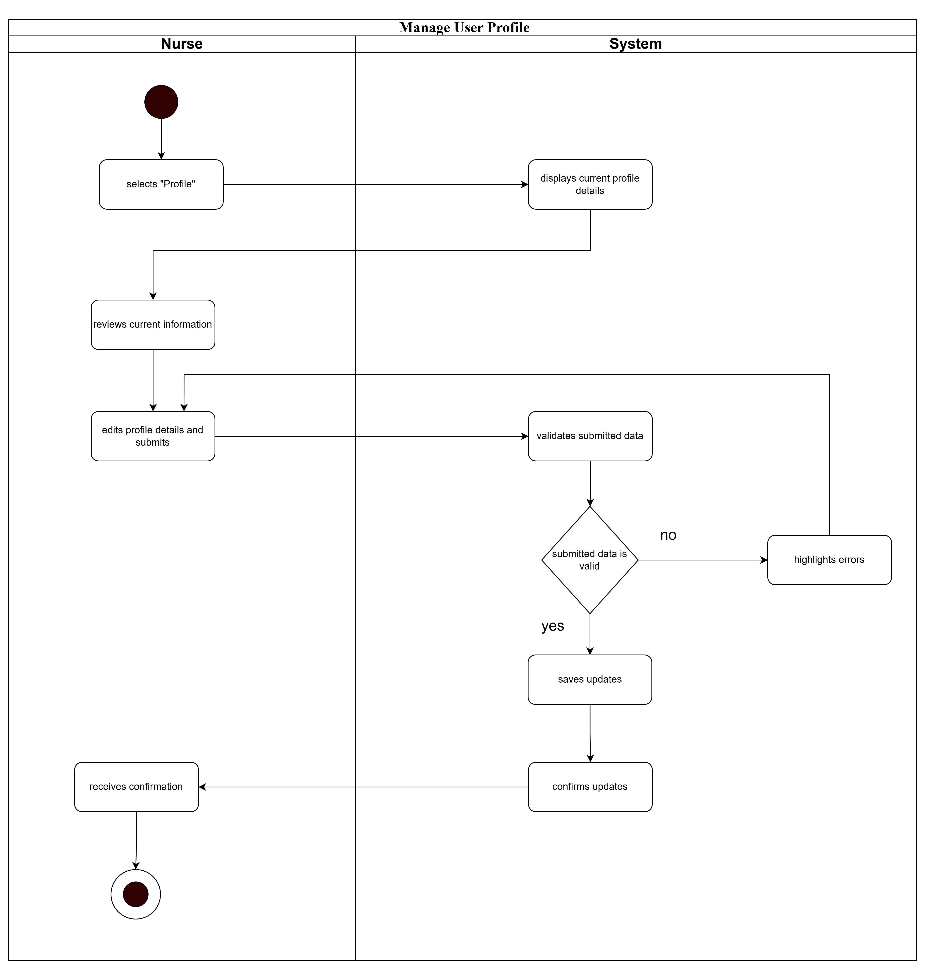

## **Activity diagram for “Manage User Profile”**

* **Manage User Profile**

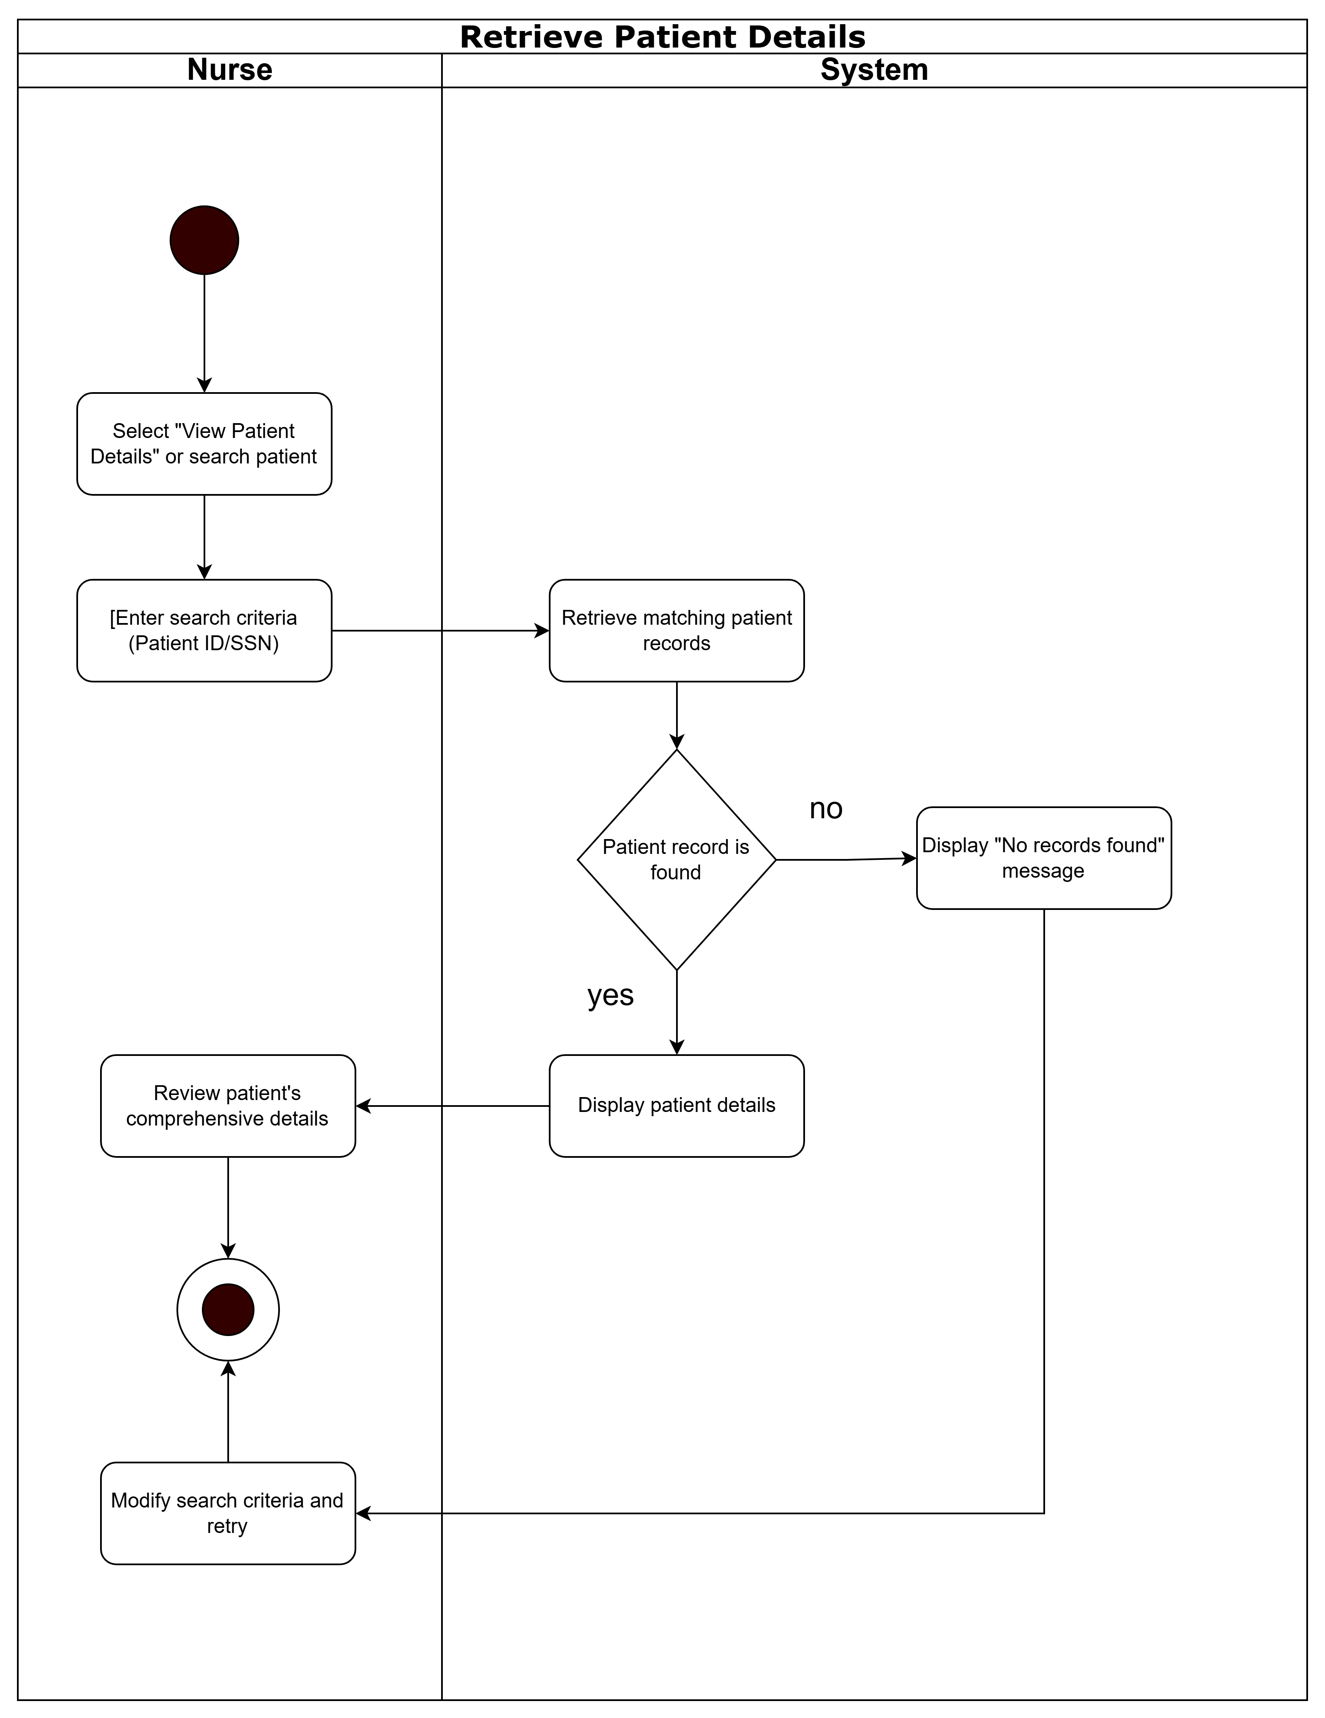

## **Activity diagram for “Manage User Profile”**

**Activity diagram to capture the business process between systems and the Administrator**

* **Login**

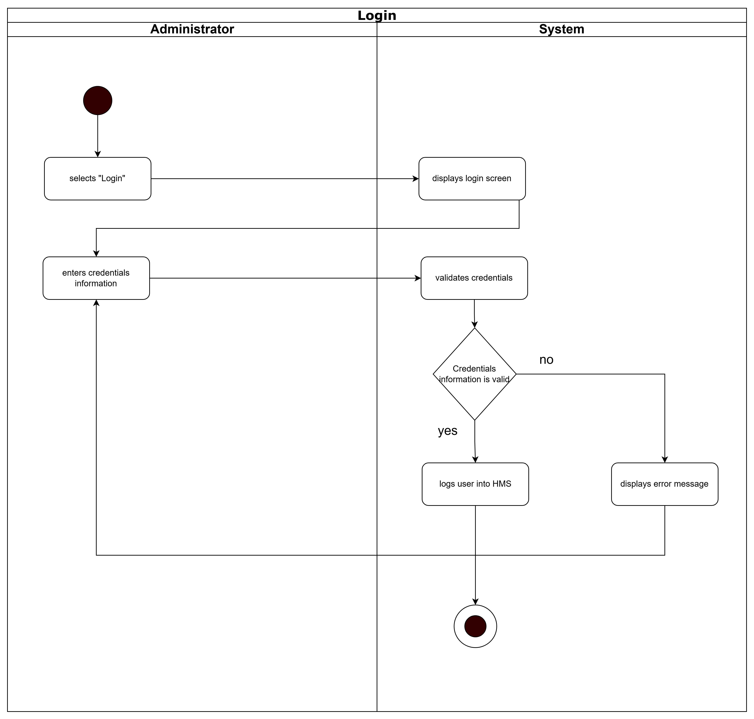

## **Activity diagram for “Manage User Profile”**

* **Add staff members**

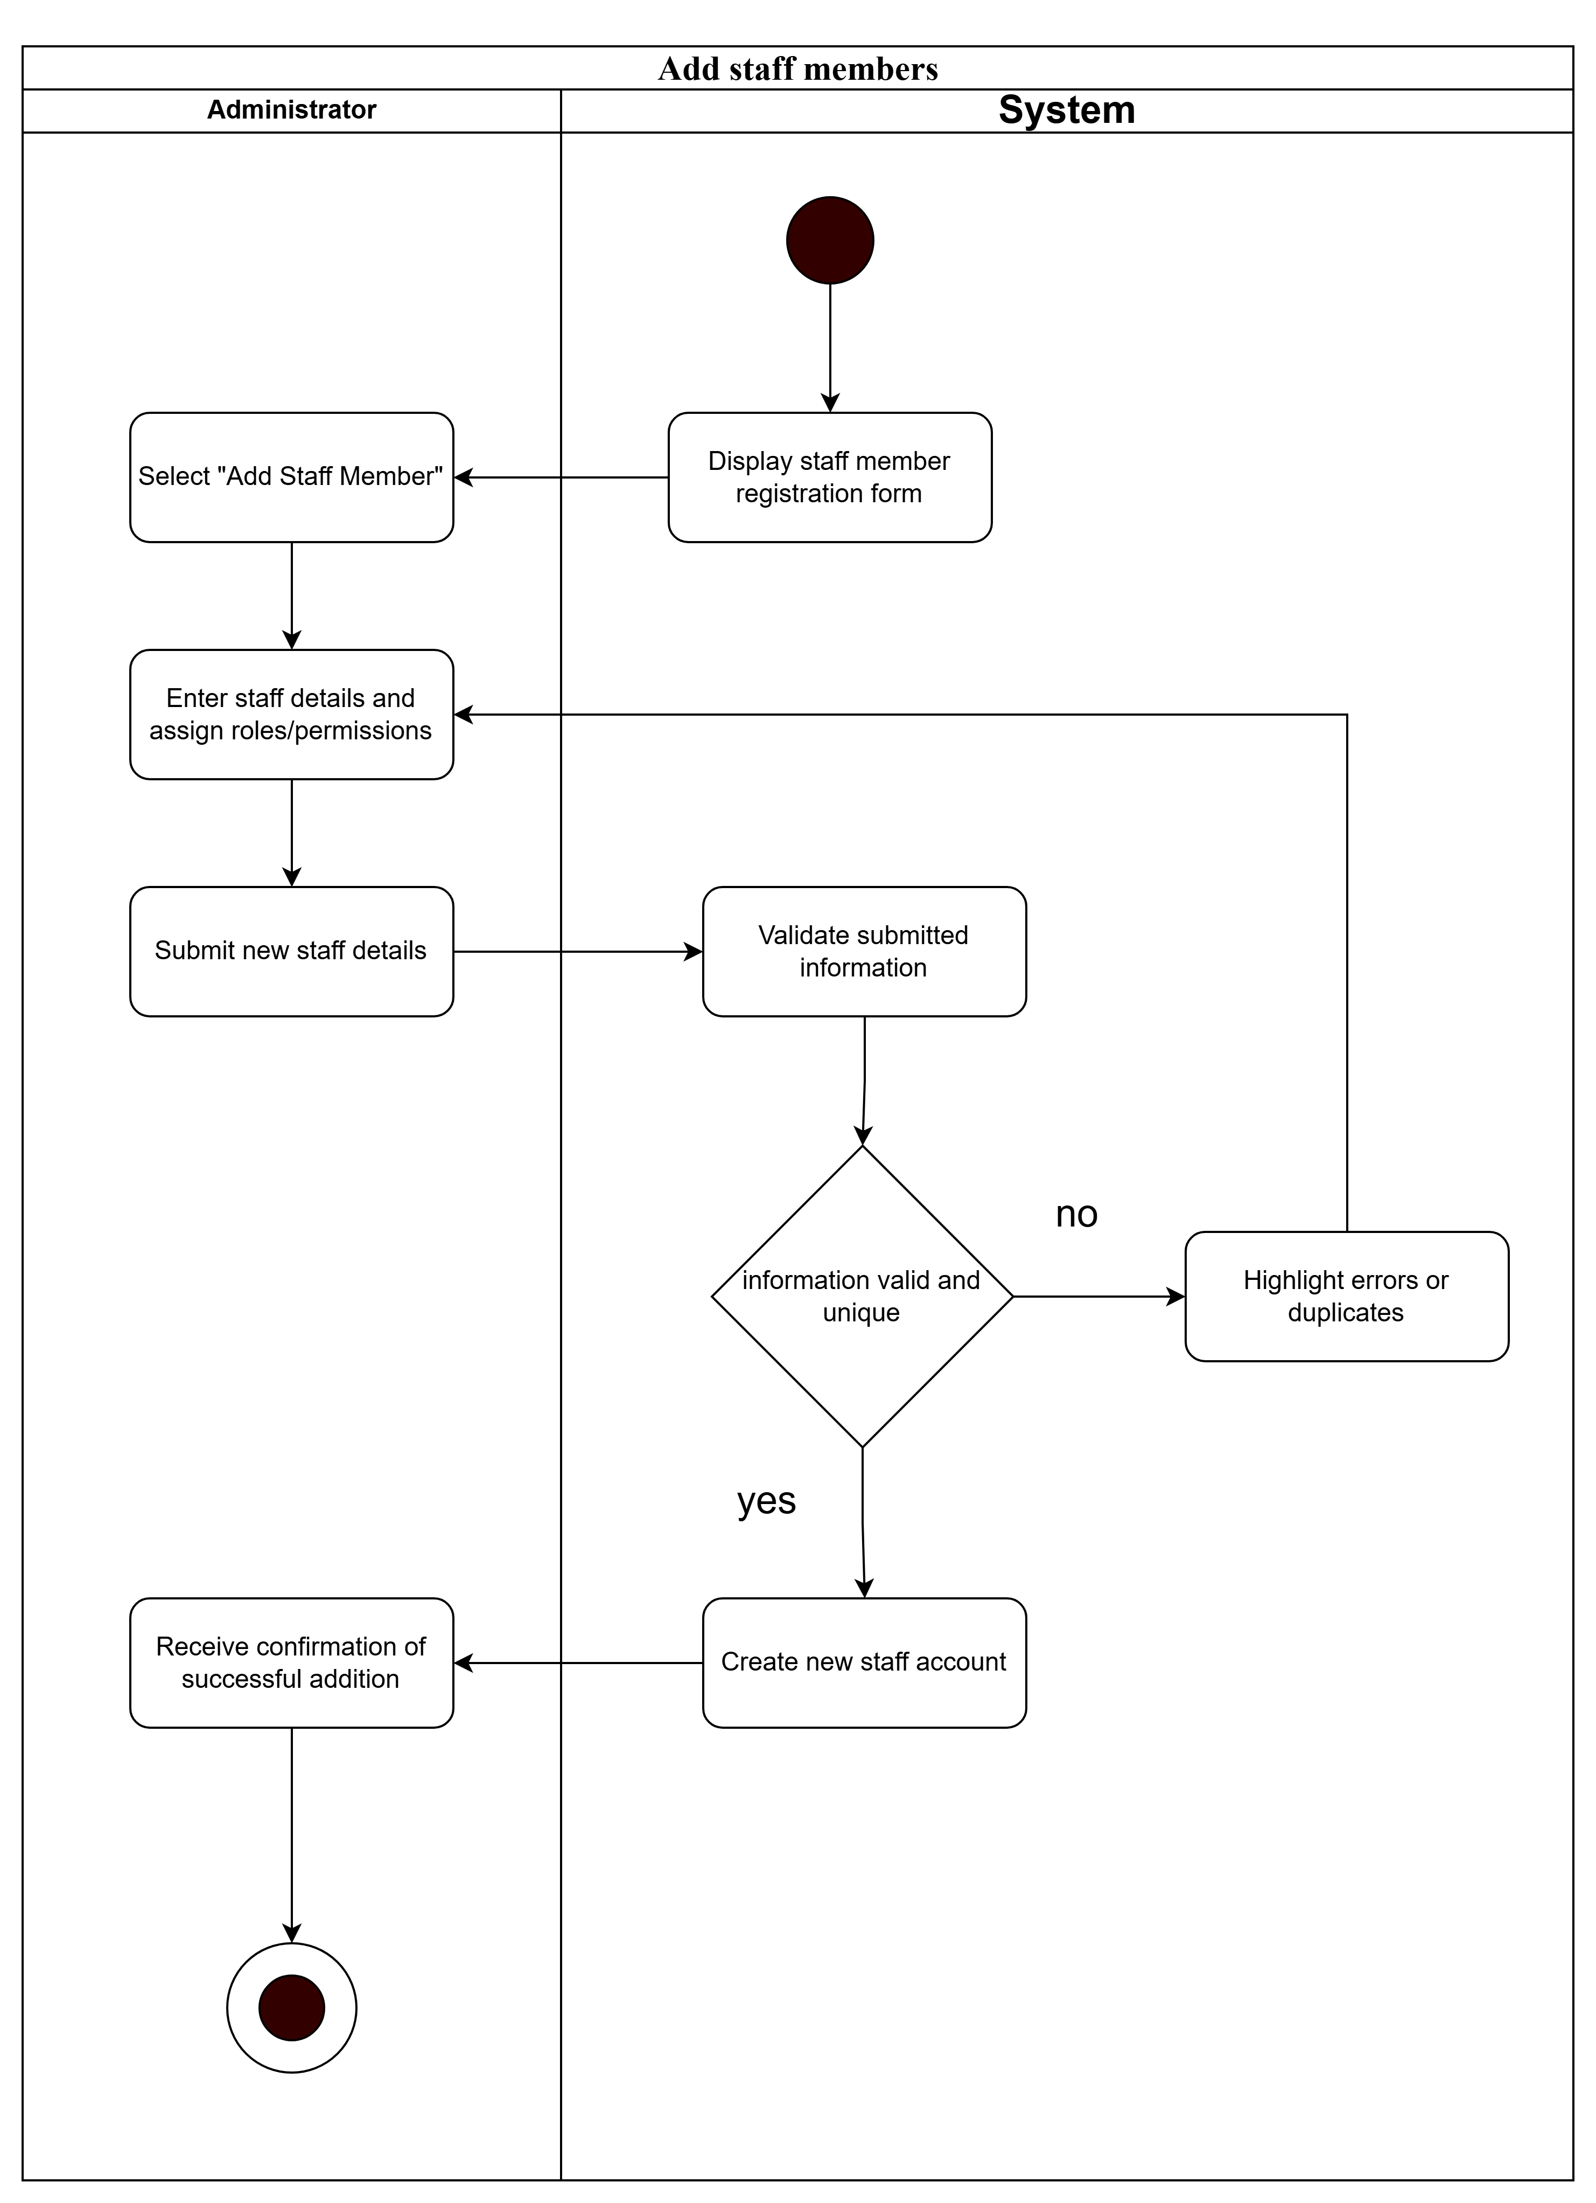

## **Activity diagram for “Add staff members”**

* **Remove staff members**

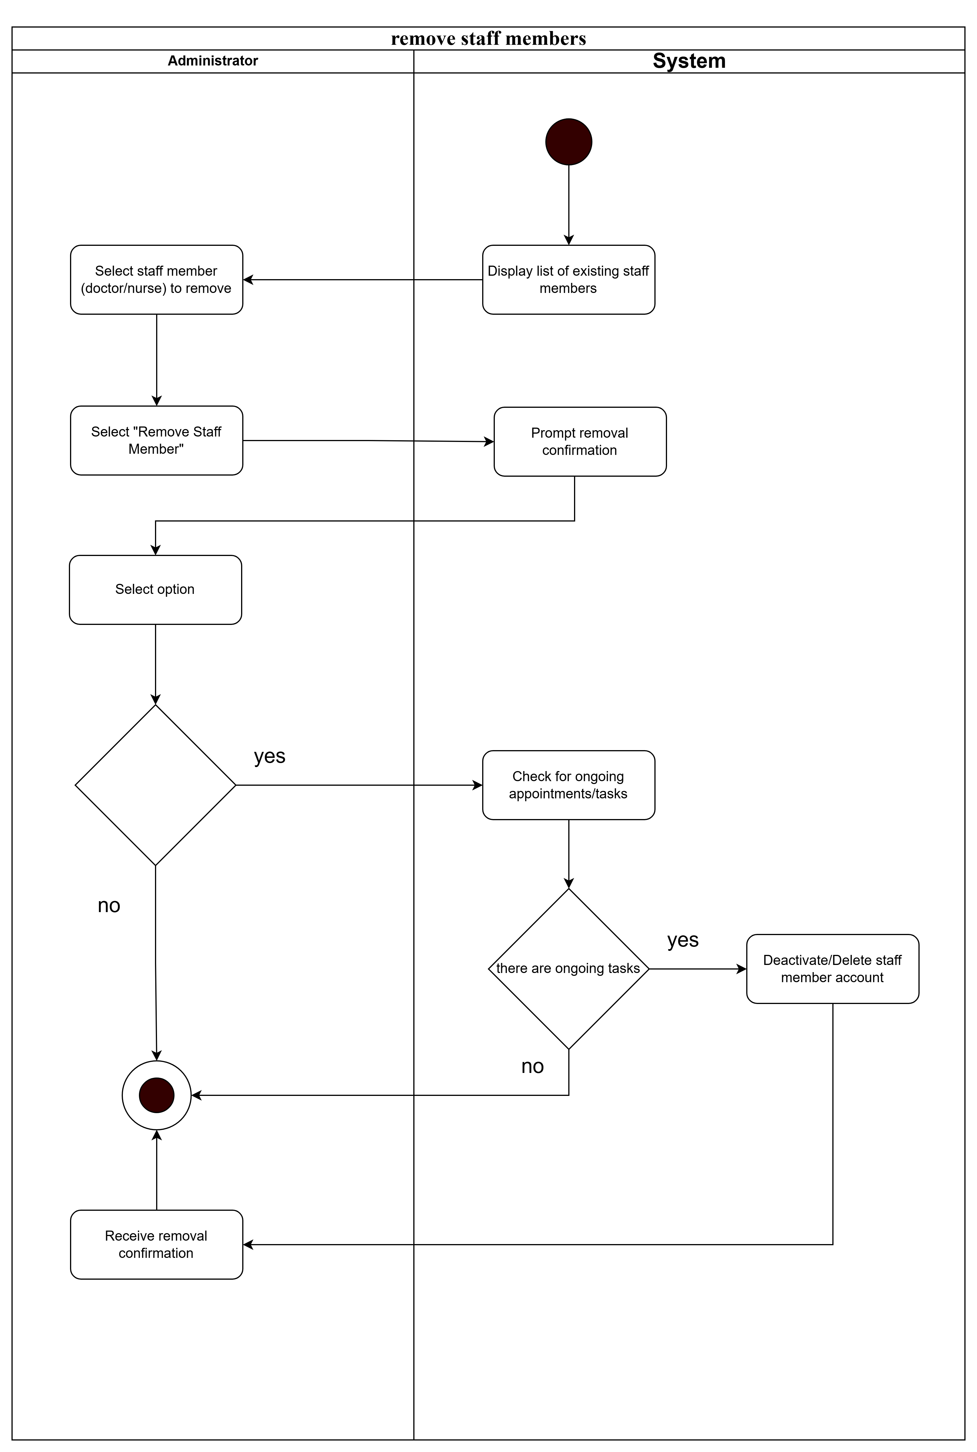

## **Activity diagram for “Remove staff members”**

## 3.2 Sequence diagram

In this part we draw sequence diagrams base on modules that we demonstrated in the last part.

* **Login**

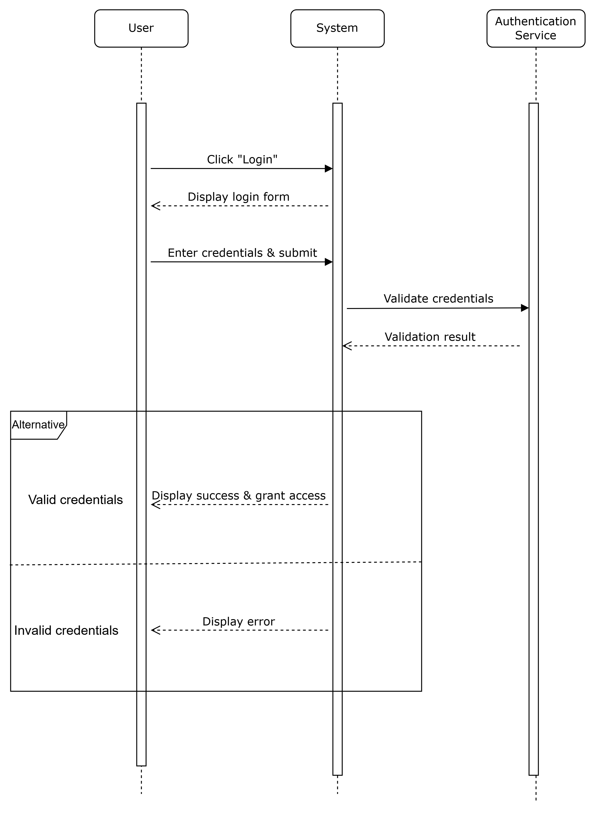

**Sequence diagram for “Login”**

In this sequence diagram, the student initiates the login process by entering their credentials into the system. The system receives these credentials and proceeds to verify them. If the credentials are valid, the system grants the student access. If the credentials are invalid, the system returns an error message, notifying the student that access is denied due to incorrect credentials.

* **Manage User Profile**

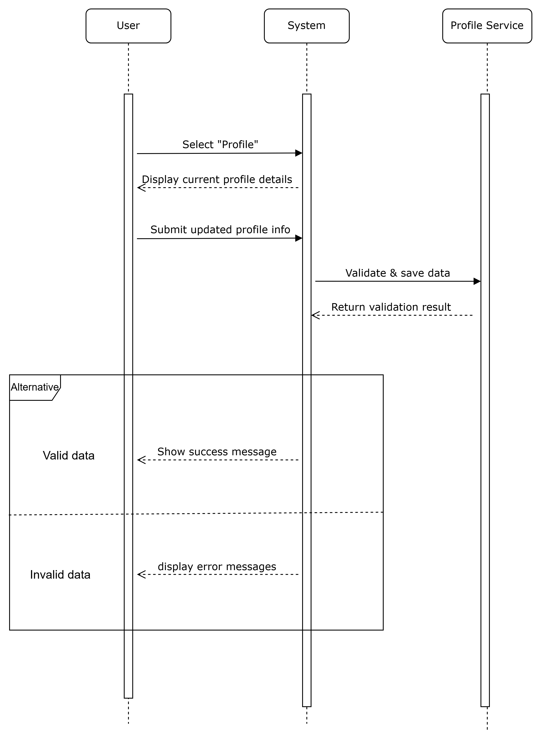

**Sequence diagram for “Manage User Profile”**

.

* **Account Registration**

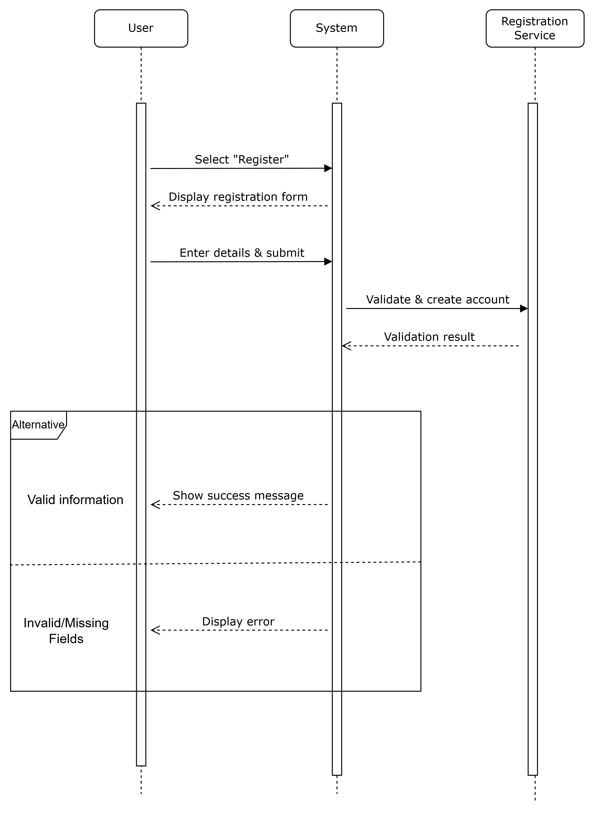

**Sequence diagram for “Account Registration”**

* **Make A Payment**

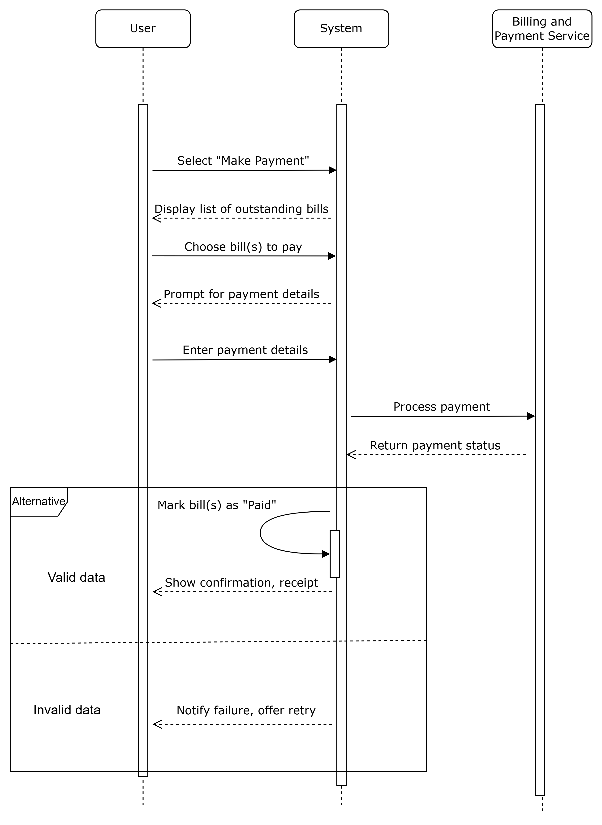

**Sequence diagram for “Make A Payment”**

* **View Bill Detail**

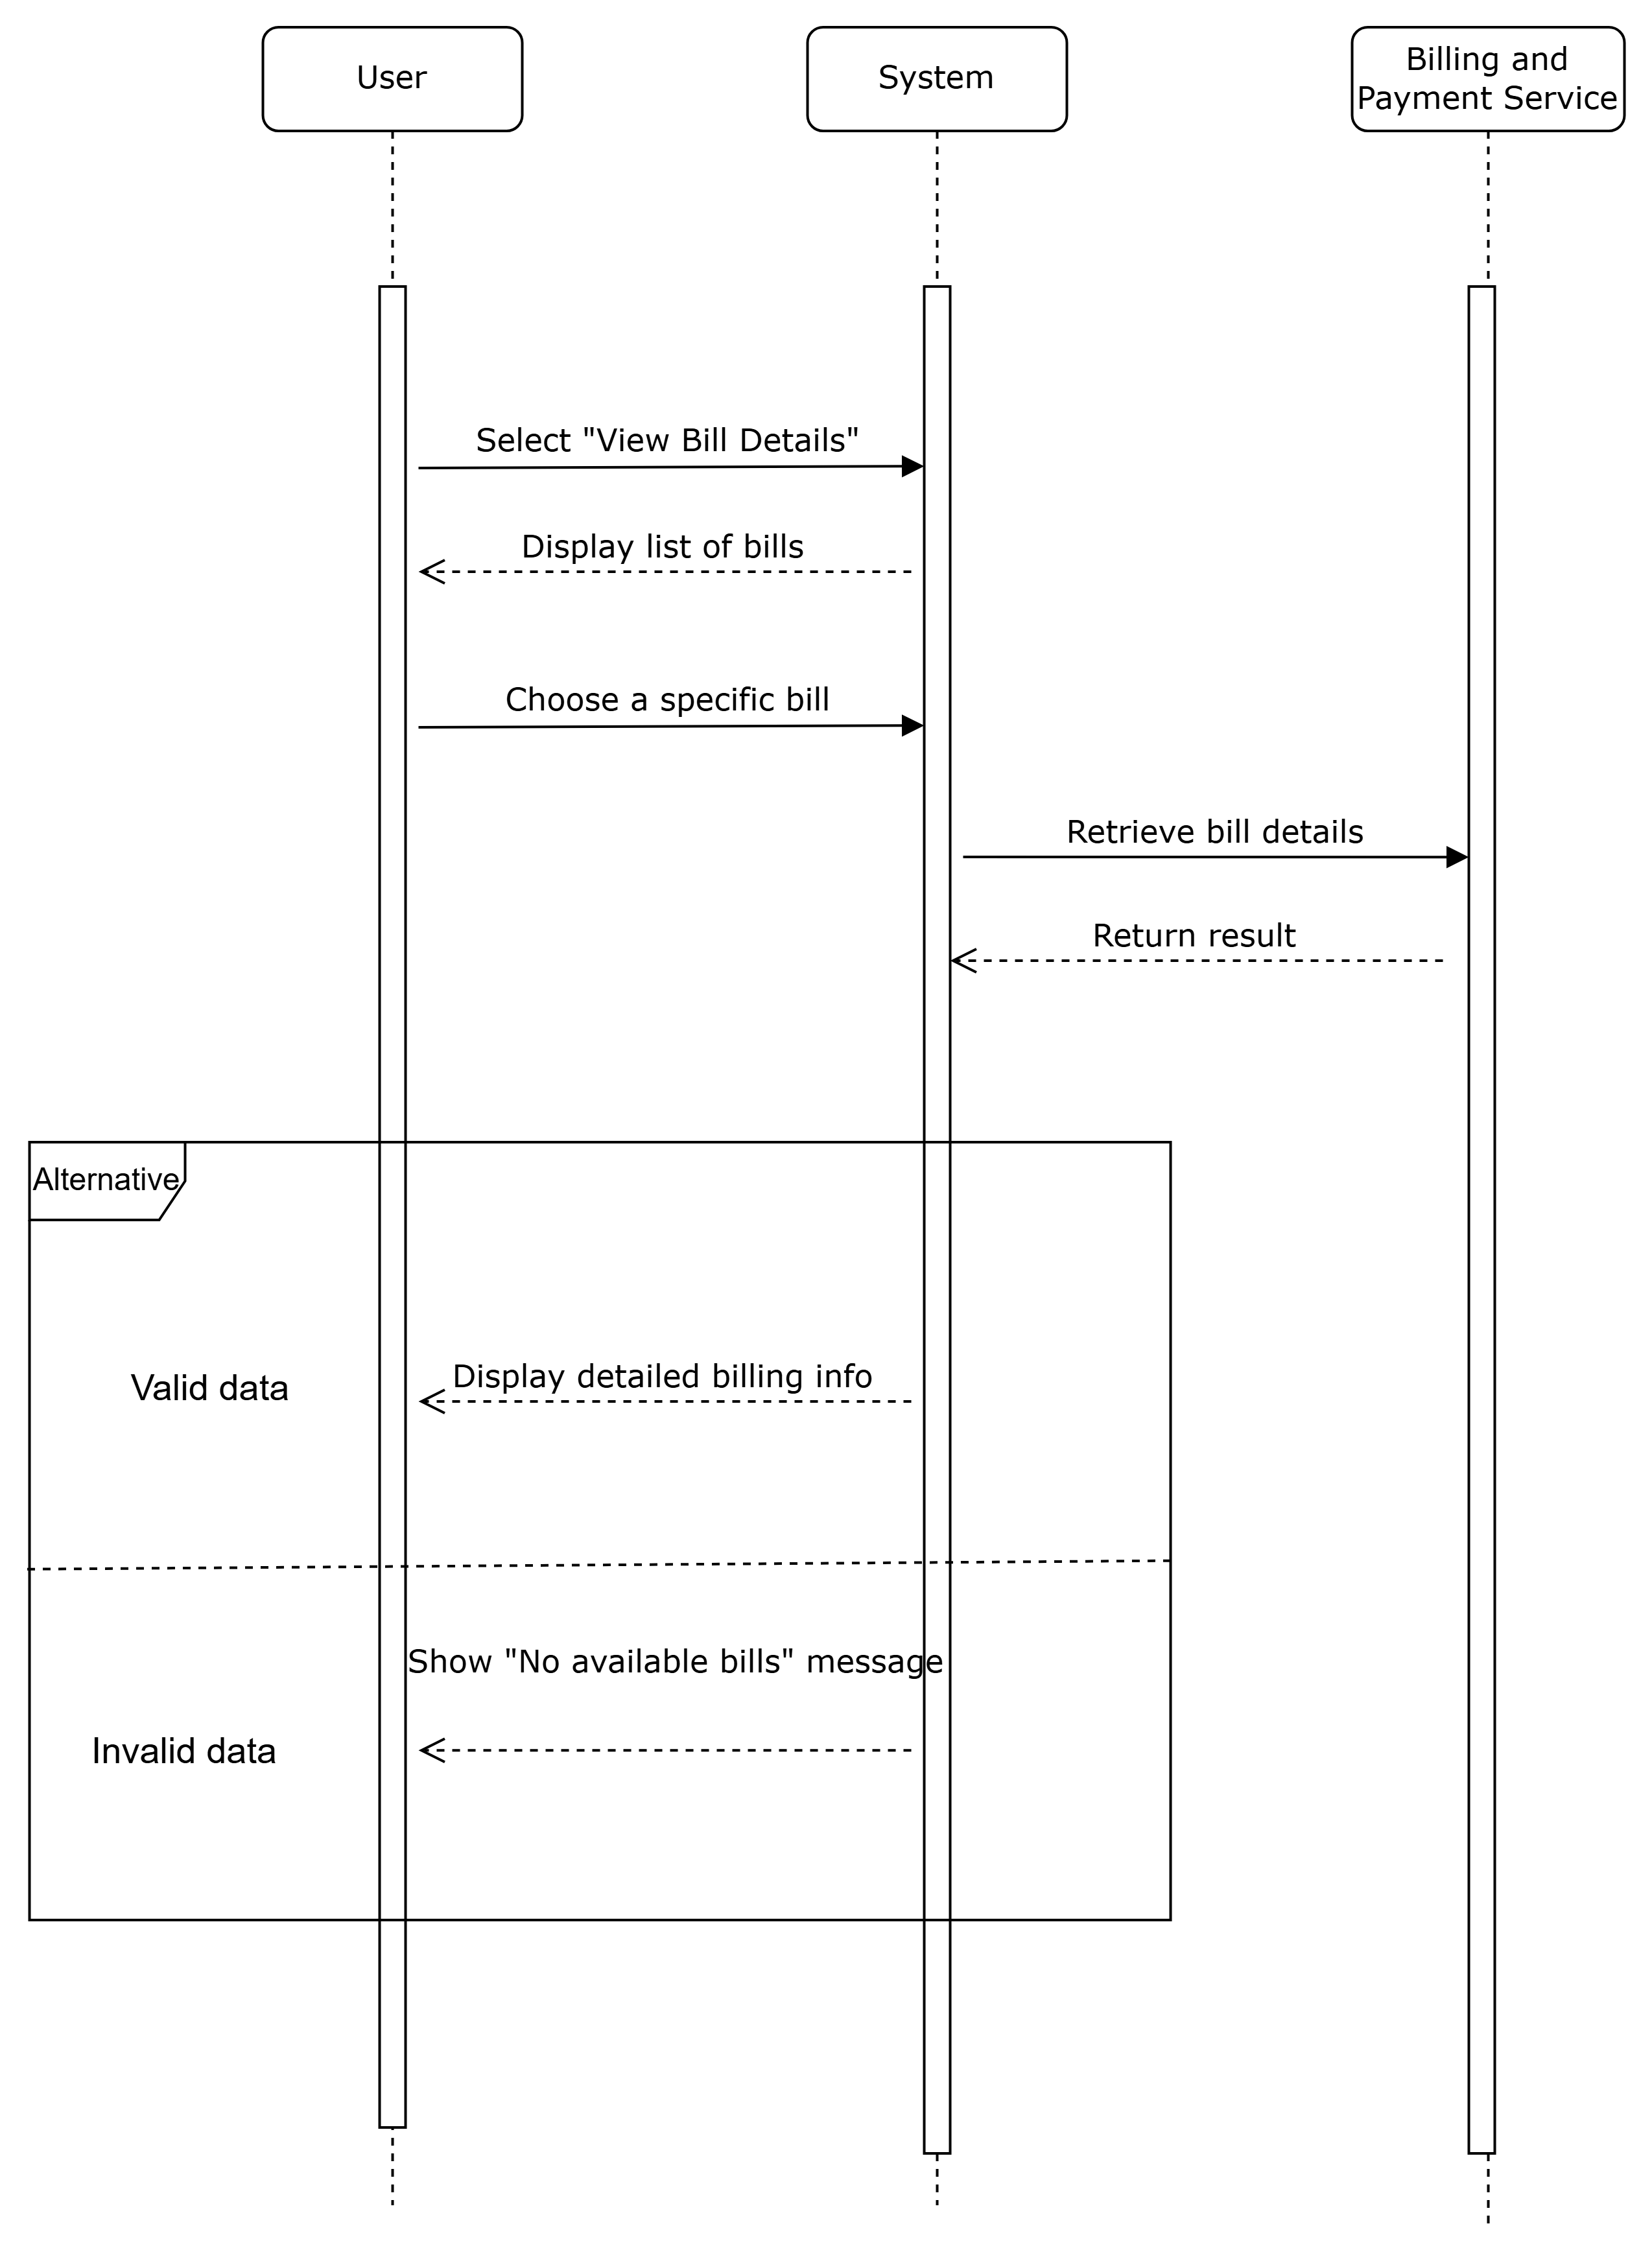

**Sequence diagram for “View Bill Detail”**

* **Making appointment**

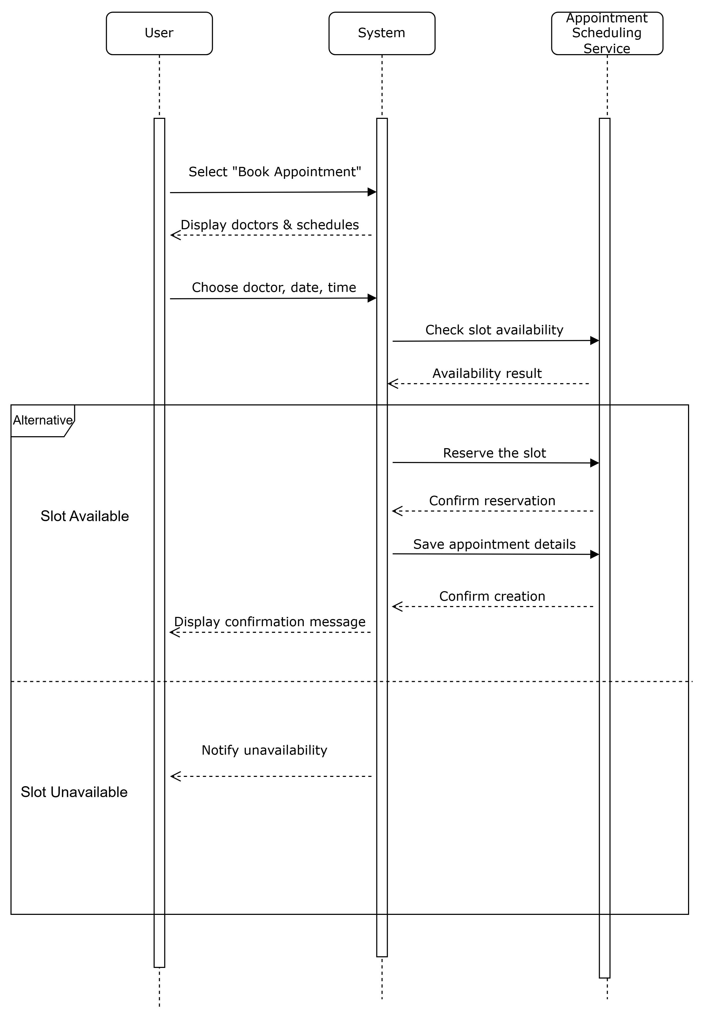

**Sequence diagram for “Making appointment”**

* **Retrieve Patient detail**

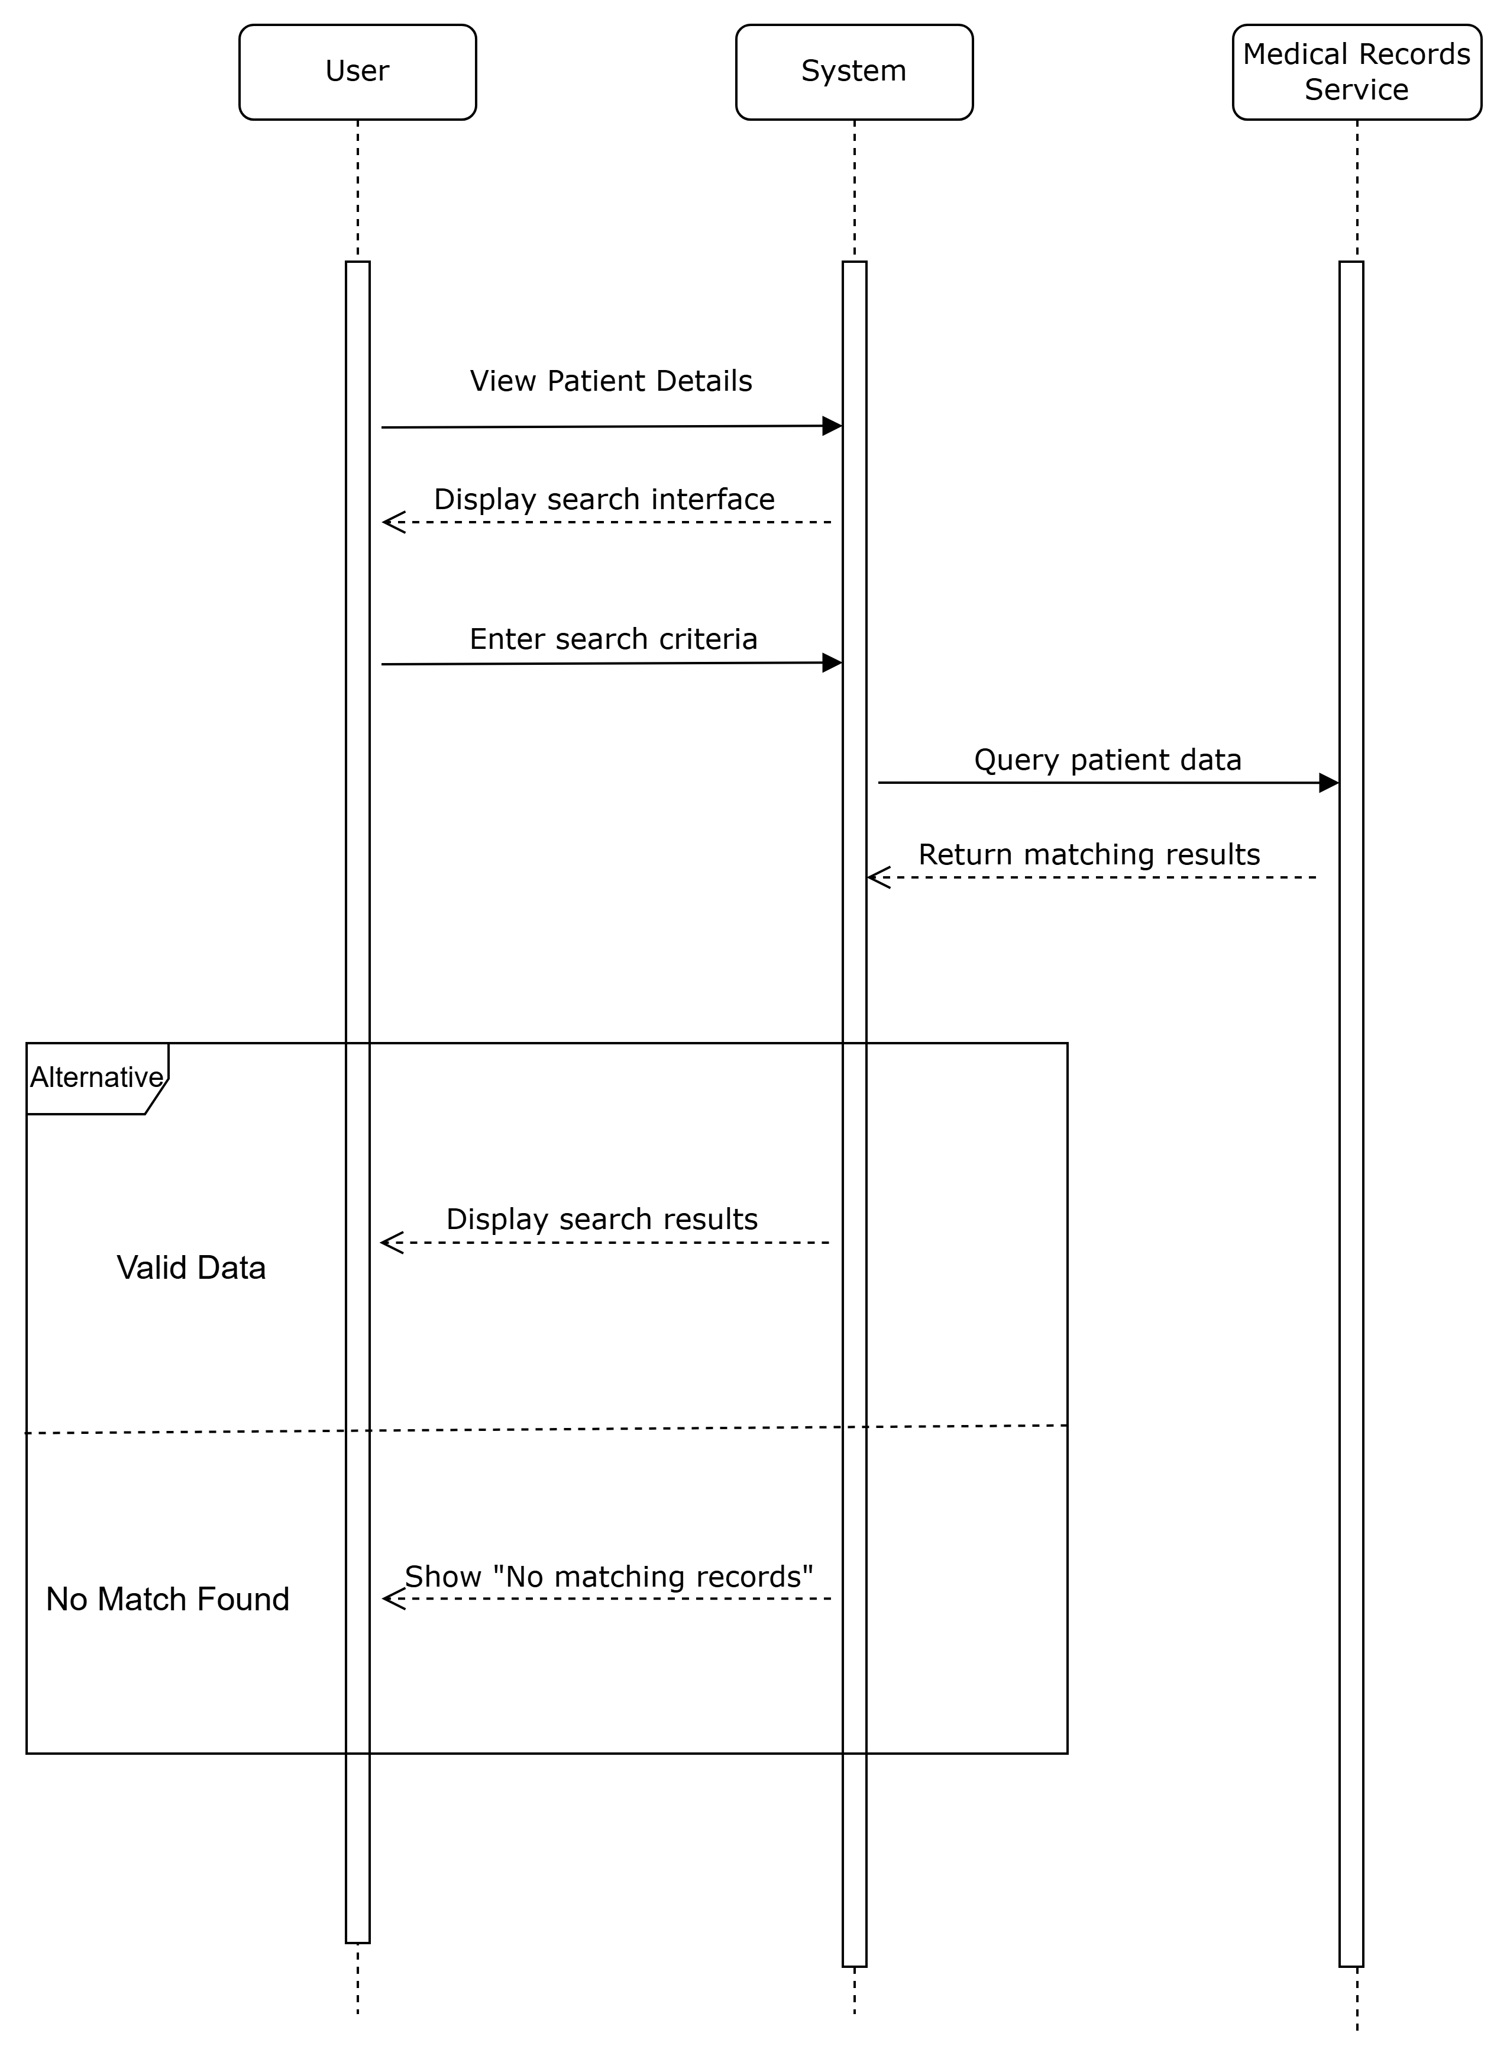

**Sequence diagram for “Retrieve Patient detail”**

* **Update Medical and Health Information**

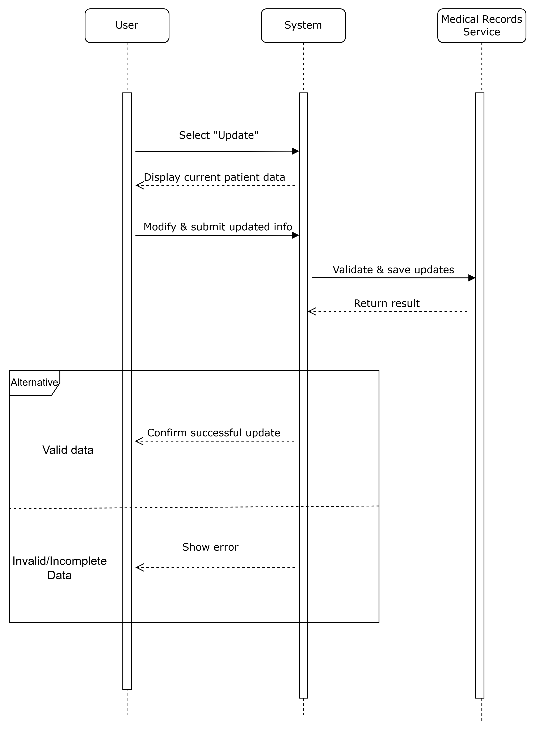

**Sequence diagram for “Update Medical and Health Information”**

* **Add Staff Member**

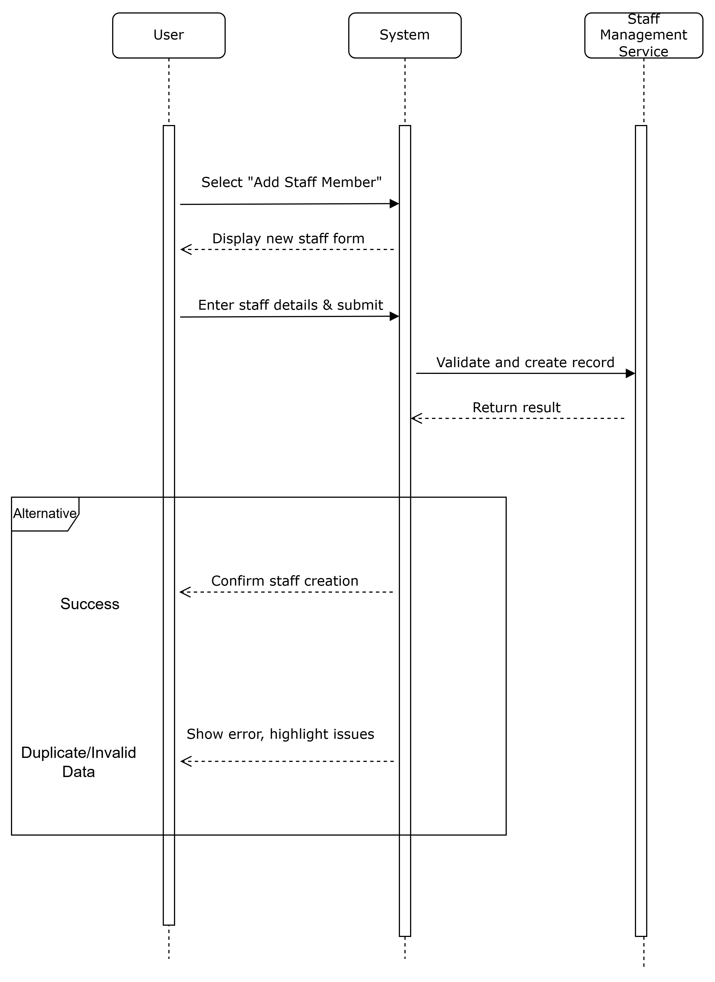

**Sequence diagram for “Add Staff Member”**

* **Remove Staff Member**

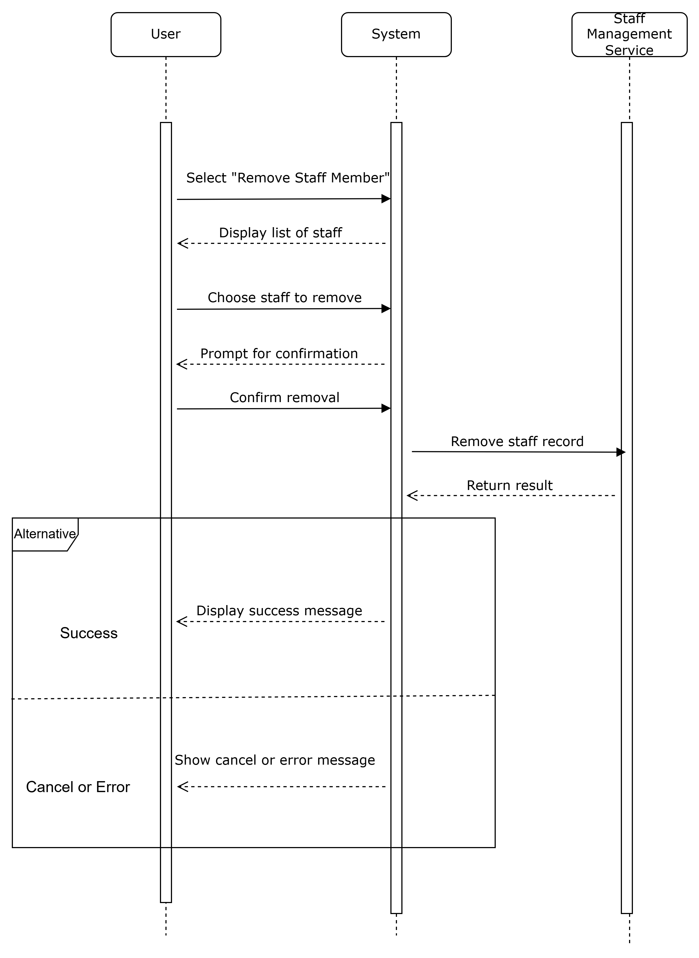

**Sequence diagram for “Remove Staff Member”**

# 4. Architecture Design

## 4.1 Architecture Diagram

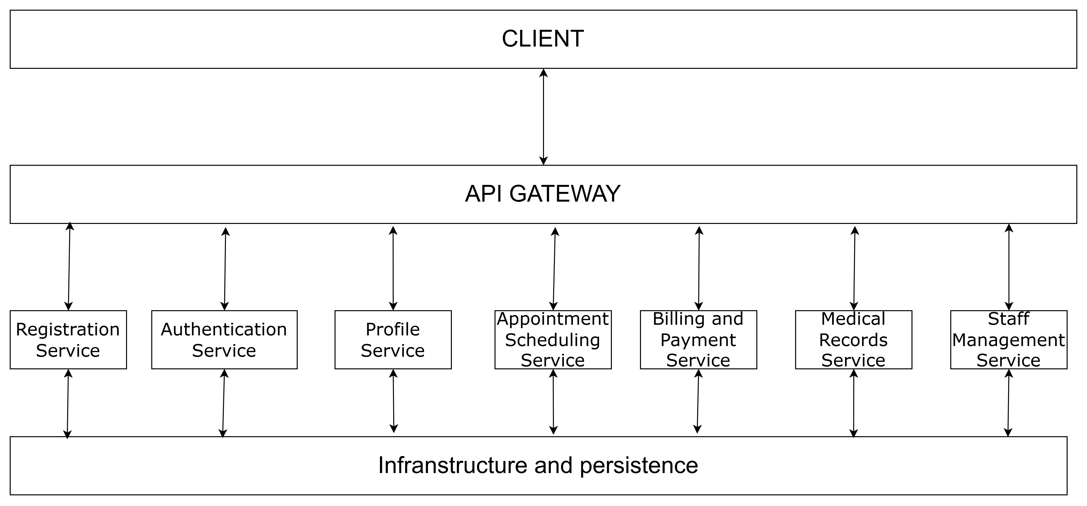

**Microservice Architecture**

The **Hospital Management System (HMS)** follows a **microservices architecture**, ensuring modularity, scalability, and maintainability. The system is designed to handle various operations, including **user authentication, appointment scheduling, medical record management, billing and payments, and staff management**. The architecture is structured into multiple **independent microservices**, each serving a specific domain while communicating through an **API Gateway**.

## 4.2 Architecture Breakdown

### 4.2.1 Client (Frontend)

### The **Client Layer** serves as the **presentation layer**, allowing patients, doctors, and administrators to interact with the system. It is structured as a **composite interface**, with individual UI components corresponding to specific microservices. The client communicates with the **API Gateway**, which routes requests to the appropriate backend services.

### 4.2.2 API Gateway

The **API Gateway** acts as a **centralized entry point** for all requests coming from the client, forwarding them to the appropriate microservices. It is responsible for **authentication, authorization, request validation, rate limiting, logging, and monitoring**.

#### ****Purpose:****

* Ensures **secure communication** between the client and backend services.
* Implements **access control** and **authentication validation**.
* **Decouples frontend from backend**, simplifying interactions.

### 4.2.3 Microservices Layer

### Each **microservice** is independently deployed, handling a distinct **business functionality**. This structure ensures **scalability**, **fault tolerance**, and **modular updates**.

1. **User Authentication Service**

· **Purpose:** Handles user login, logout, credential validation, and permissions.

· **Use Cases:**

* Patient Login/Administrator/Doctor/Nurse Login

#### ****User Profile Service****

* **Purpose:** Manages user profile details (viewing/updating patient and staff information).
* **Use Cases:**
  + Manage User Profile

#### ****Patient Registration Service****

* **Purpose:** Handles patient account creation, verification, activation.
* **Use Cases:**
  + Patient Account Registration

#### ****Appointment Scheduling Service****

* **Purpose:** Manages appointment bookings, doctor availability, and cancellations.
* **Use Cases:**
  + Patient Booking Appointment with Doctor

#### ****Billing and Payment Service****

* **Purpose:** Manages invoices, bill payments, and financial transactions.
* **Use Cases:**
  + Patient Viewing Bill Details
  + Patient Making Payment

#### ****Medical Records Service****

* **Purpose:** Manages secure storage and retrieval of patient health data.
* **Use Cases:**
  + Doctor Retrieve Patient Details
  + Doctor Update Medical and Health Information

#### ****Staff Management Service****

* **Purpose:** Handles adding, updating, and removing doctors/nurses.
* **Use Cases:**
  + Administrator Add/Remove Staff Member

# Reference: